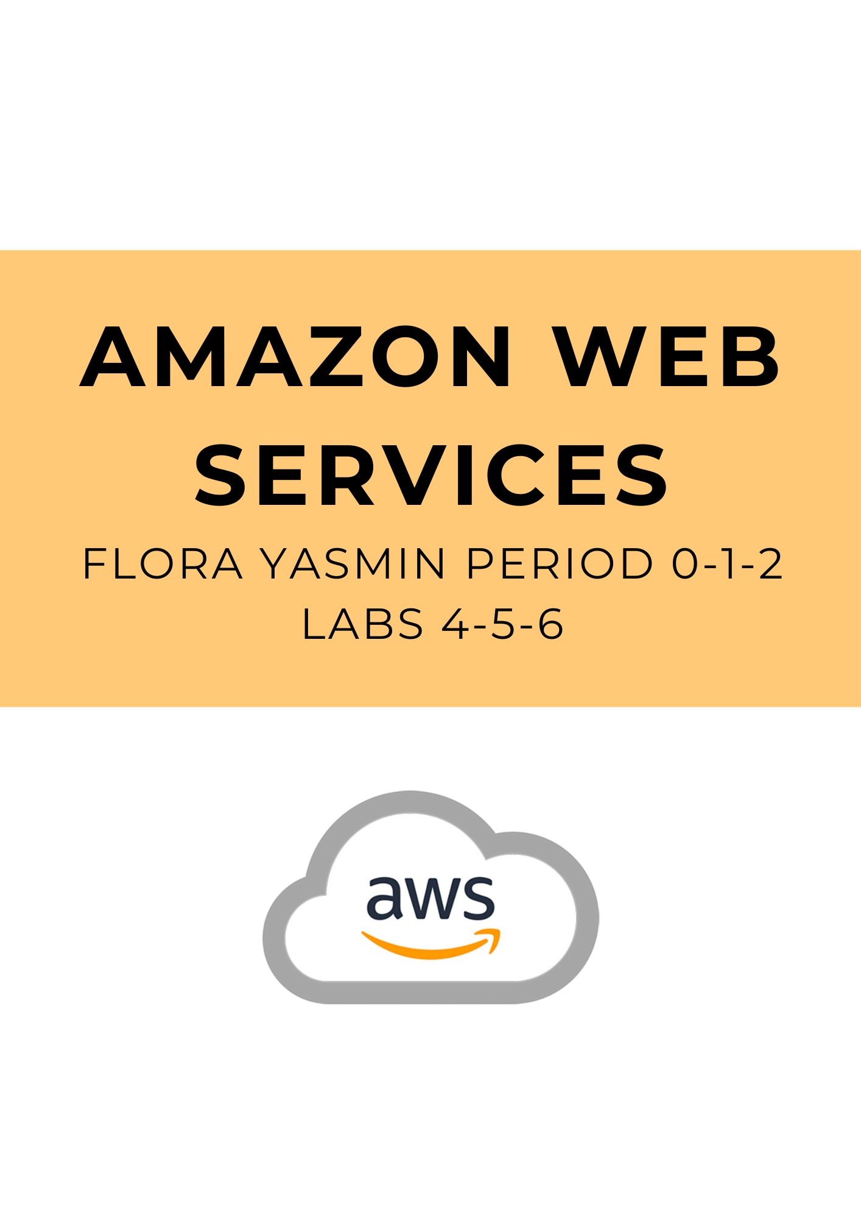**Lab 4: Working with EBS**

**Purpose**

This lab explores the Amazon Elastic Block Store (EBS), a storage mechanism used for Amazon EC2 instances. This lab walks through creating an Amazon EBS volume and attach it to an instance, apply a file system, and take a snapshot of it for backup.

**Background Information**

To complete this lab, its useful to have knowledge about Amazon EC2, a concept we have covered in previous AWS labs.

This lab builds on our EC2 knowledge, enabling us to use Amazon Elastic Block Store (Amazon EBS) for EC2 instance storage. Amazon EBS volumes provides block level storage and are similar to raw, unformatted block devices. You can create a file system on these volumes, or use them similar to any other block device, such as hard drives. What makes EBS volumes special is their quality of being highly available and reliable when used as a boot partition—the volume of a computer that holds system files of the operating system—or when attached to EC2 instances.

When using EBS as a boot partition, EC2 instances can be stopped and restarted, which enforces Amazon’s “pay-as-you-go” service since you only have to pay for the storage resources used when maintaining the instance state. Amazon EBS volumes make EC2 instances more durable as well, since they are automatically duplicated on an Availability Zone.

Additionally, EBS grants AWS users the ability to create snapshots of volumes that are stores in Amazon S3 (Simple Storage Service) and are also replicated across Availability Zones. Snapshots can be used as a template to create new Amazon EBS volumes and can protect data for longer terms. These snapshots are easily shareable as well, making AWS a great service to use among co-workers and other developers.

Some features of Amazon EBS Volume include: persistent storage for an Amazon EC2 instance; the ability to be used as block devices for any operating system; being equal or better than local EC2 drives; having built-in redundancy within Availability Zones; high resiliency (with an Annual Failure Rate of 0.1% to 1%); having a wide range of volume sizes available to use; and being simple to use as EBS volumes can be easily created, attached, backed up, restored, and deleted.

**Lab Procedures**

Task 1: Create a New EBS Volume

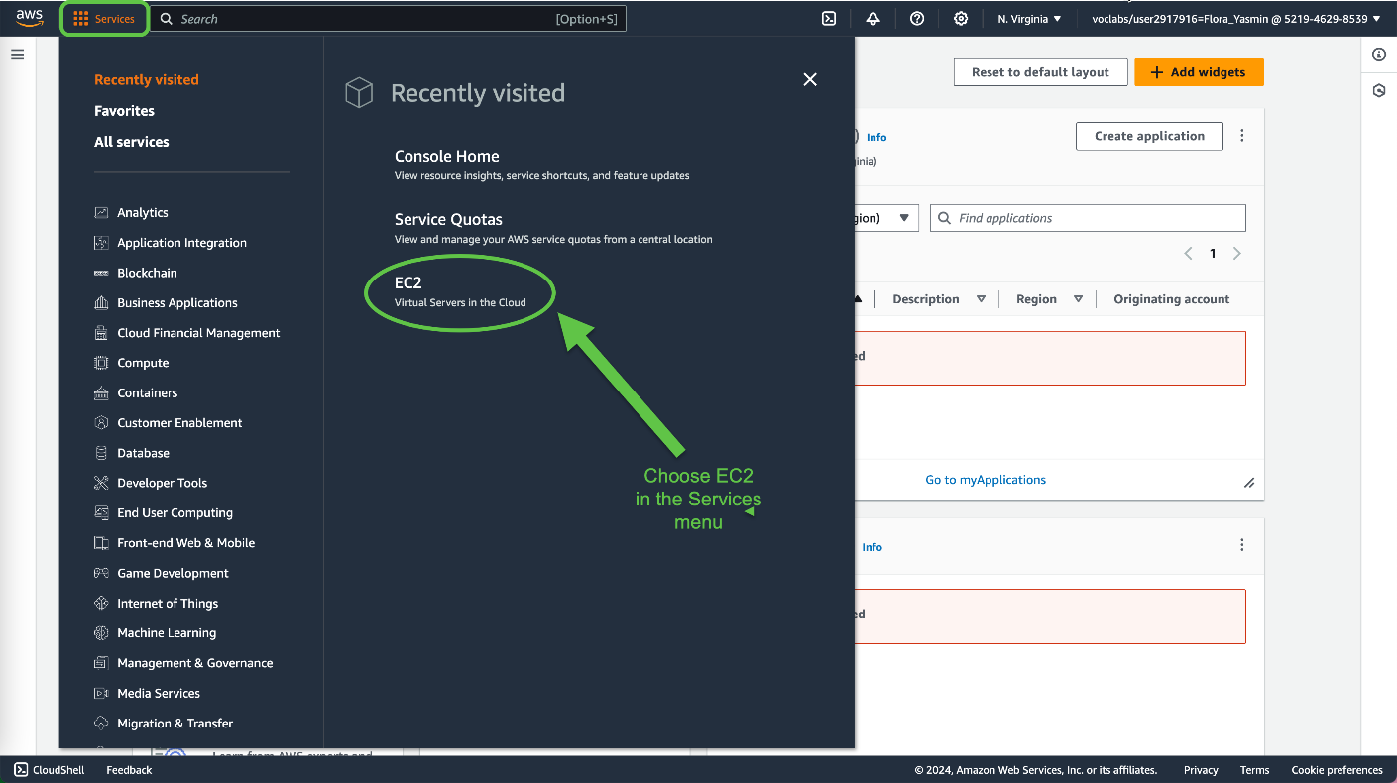

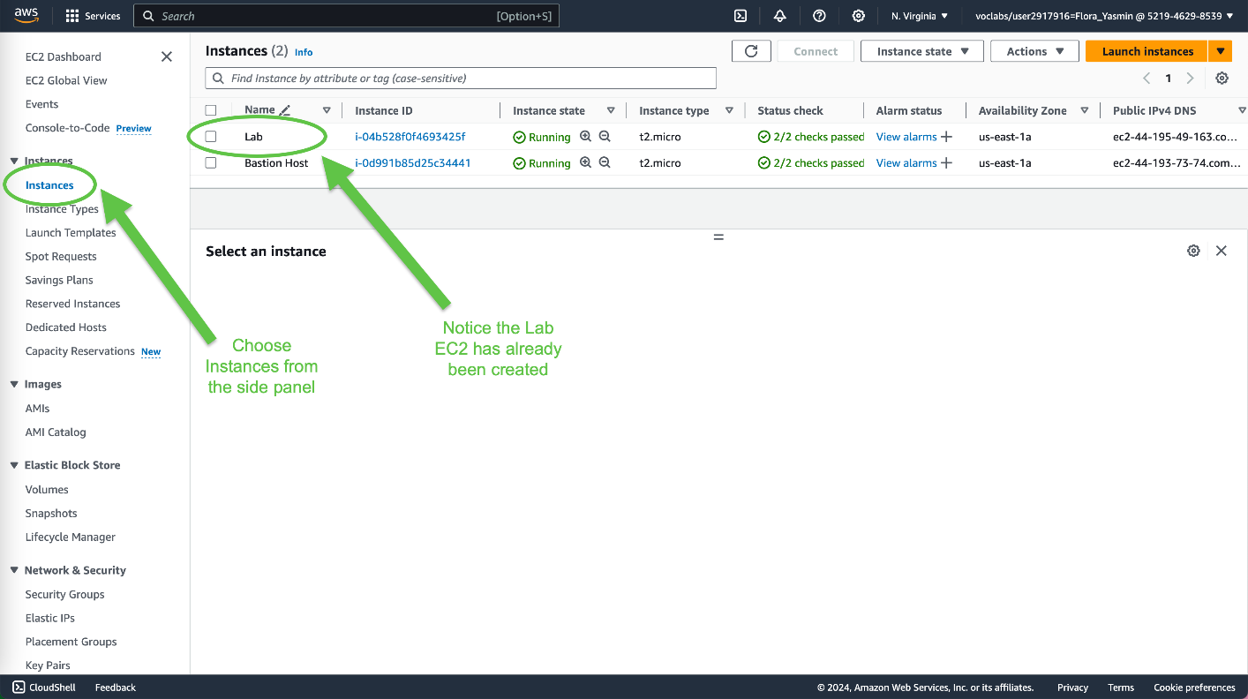

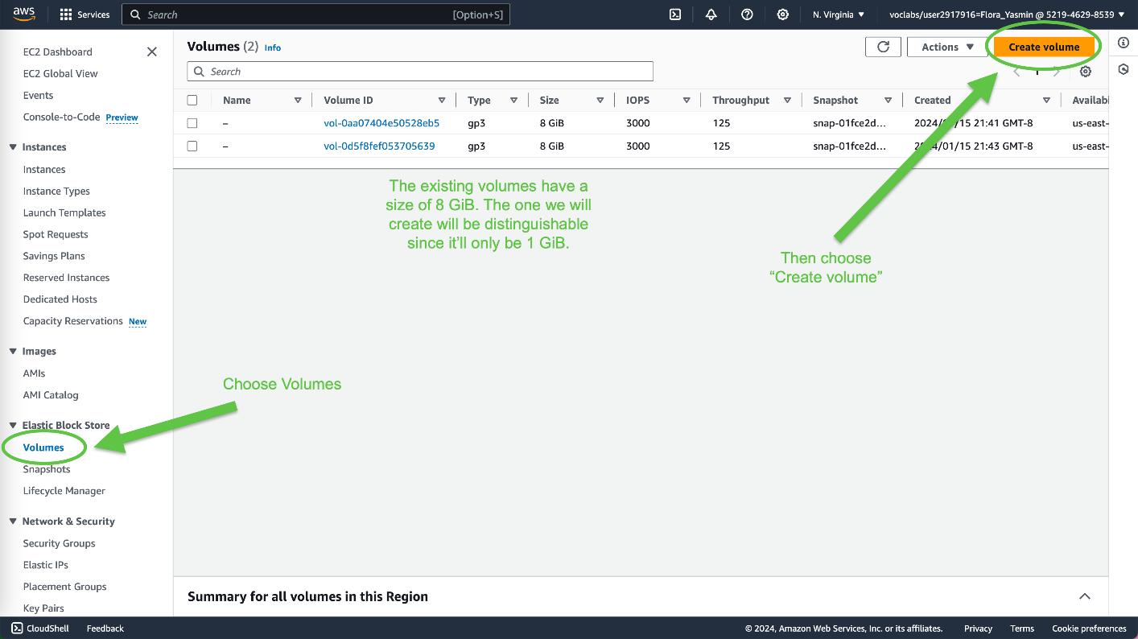

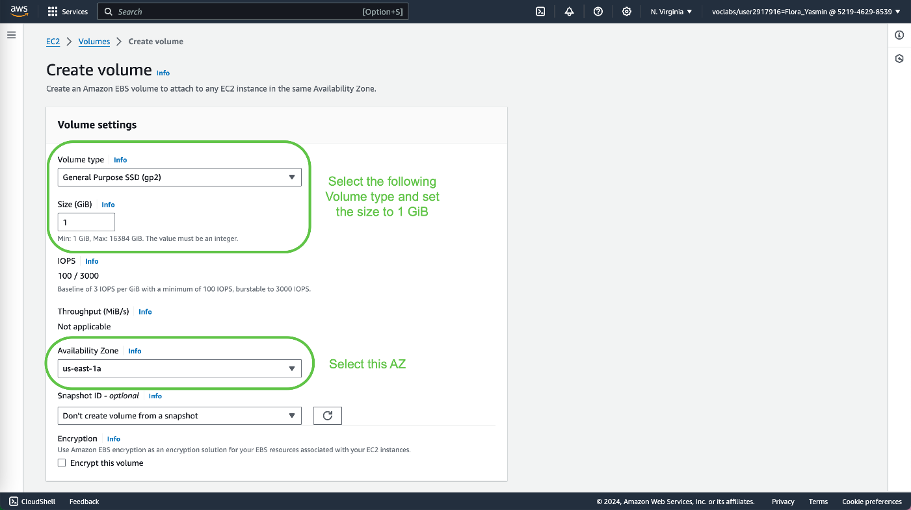

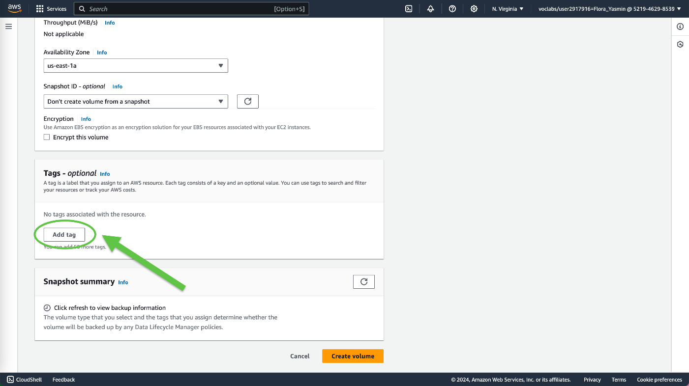

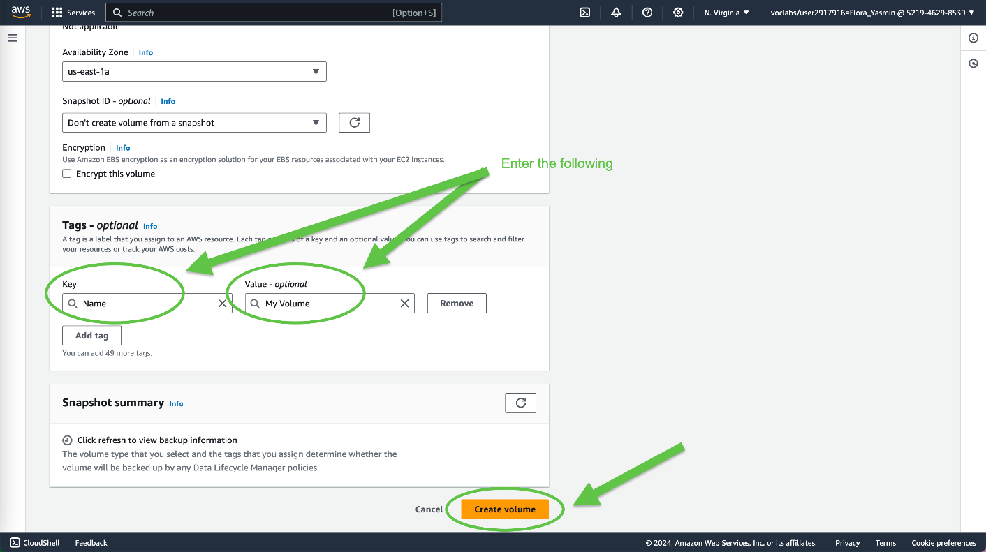

Wait for the Volume state to display “Available”

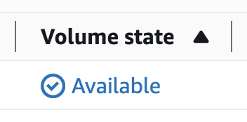

Task 2: Attach the Volume to an Instance

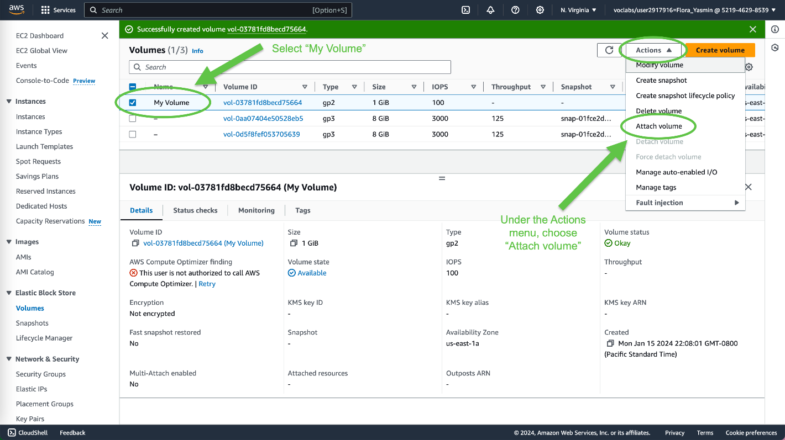

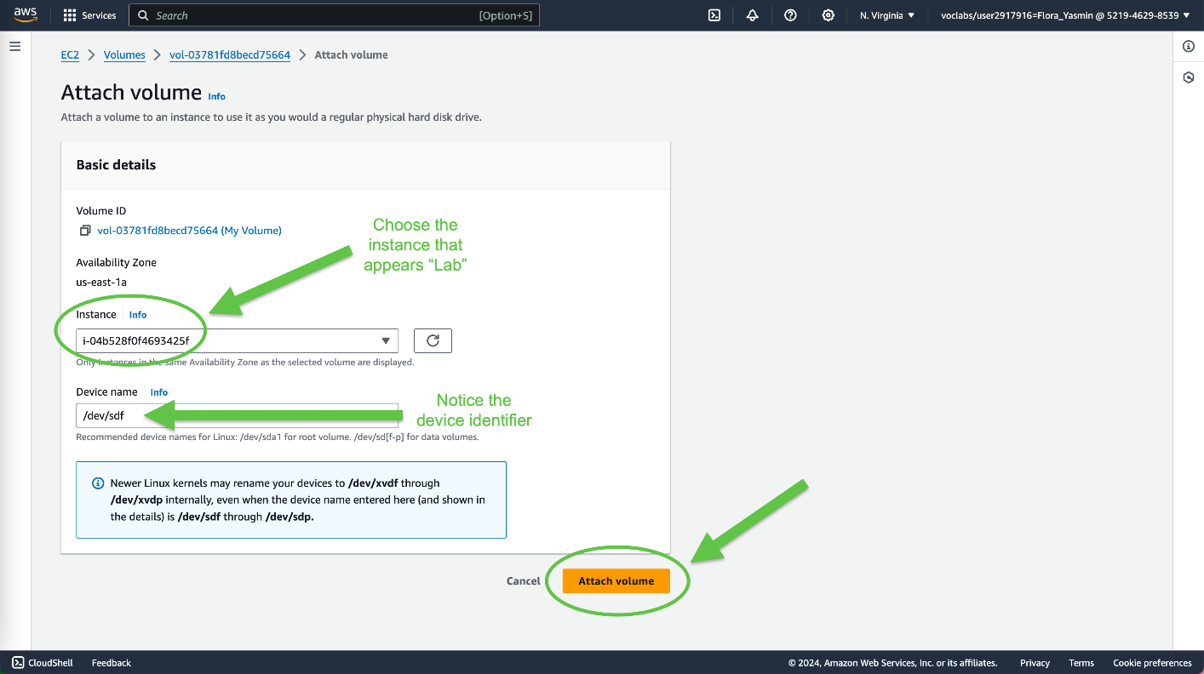

The volume state is now *in-use.*

Task 3: Connect to Your Amazon EC2 Instance

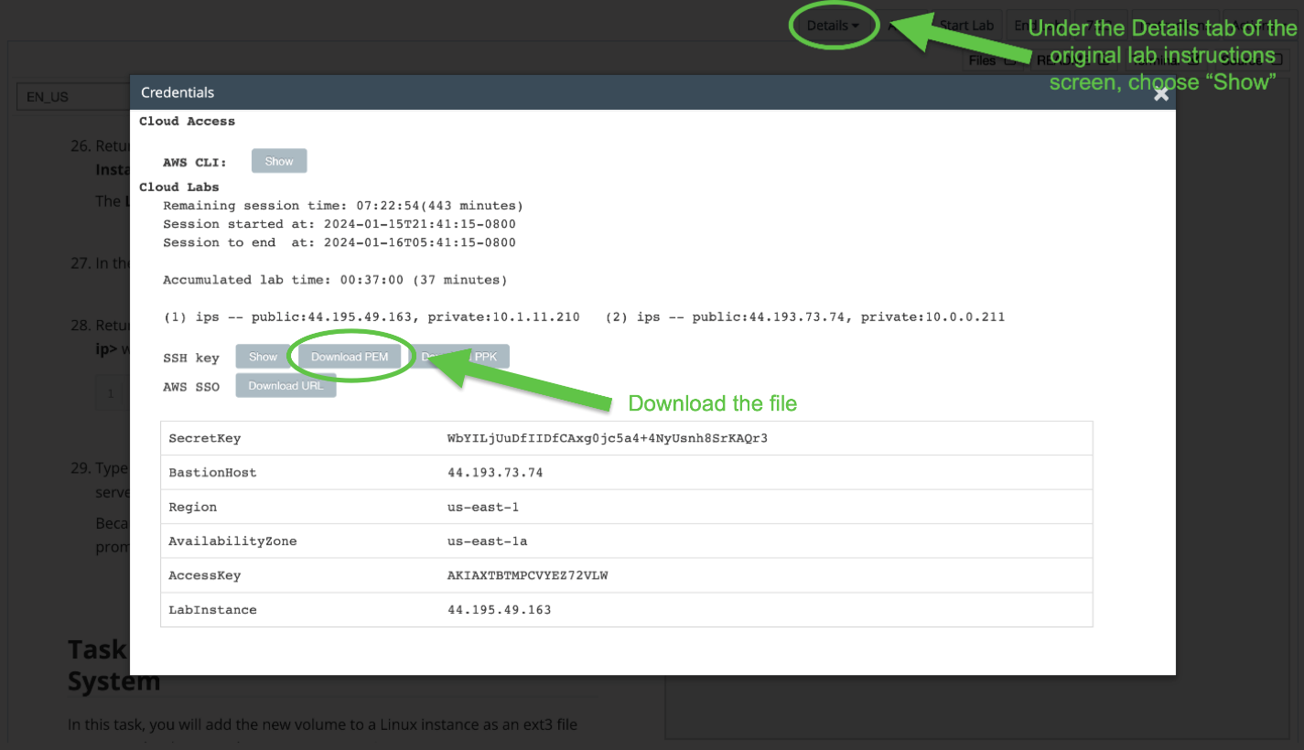

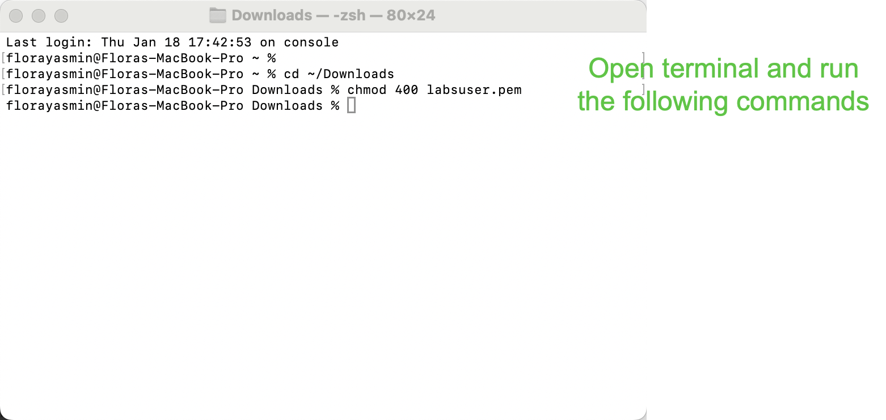

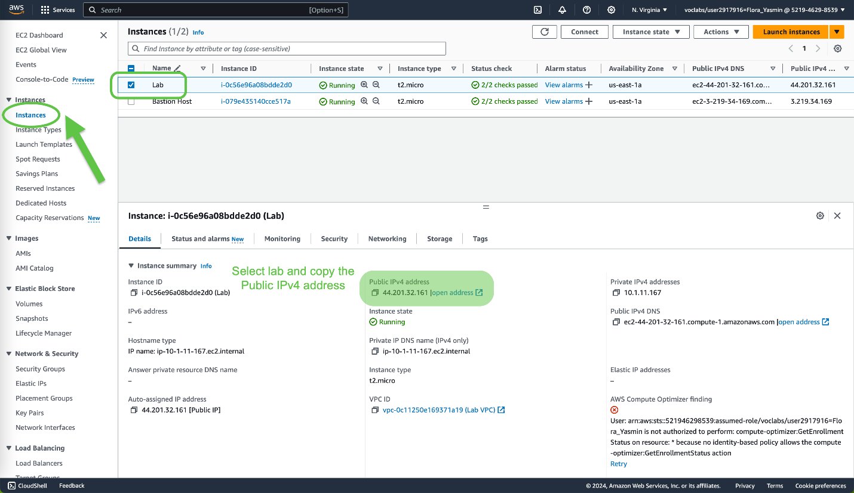

Go back to the terminal tab and enter the following commands with the Public IPv4 address:

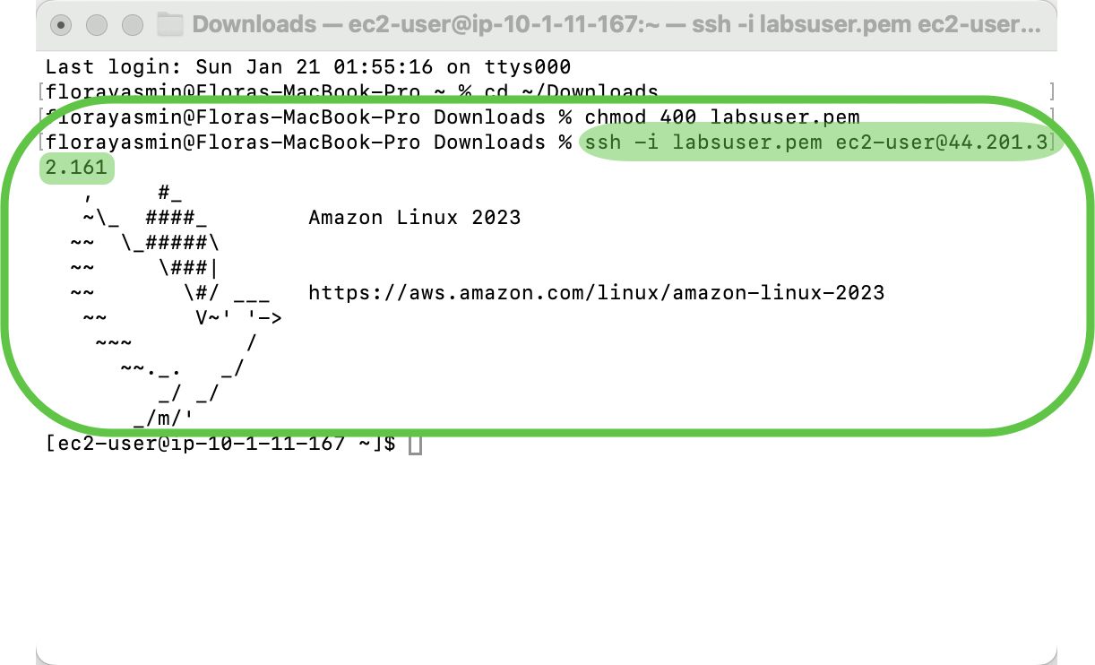

Task 4: Create and Configure Your File System

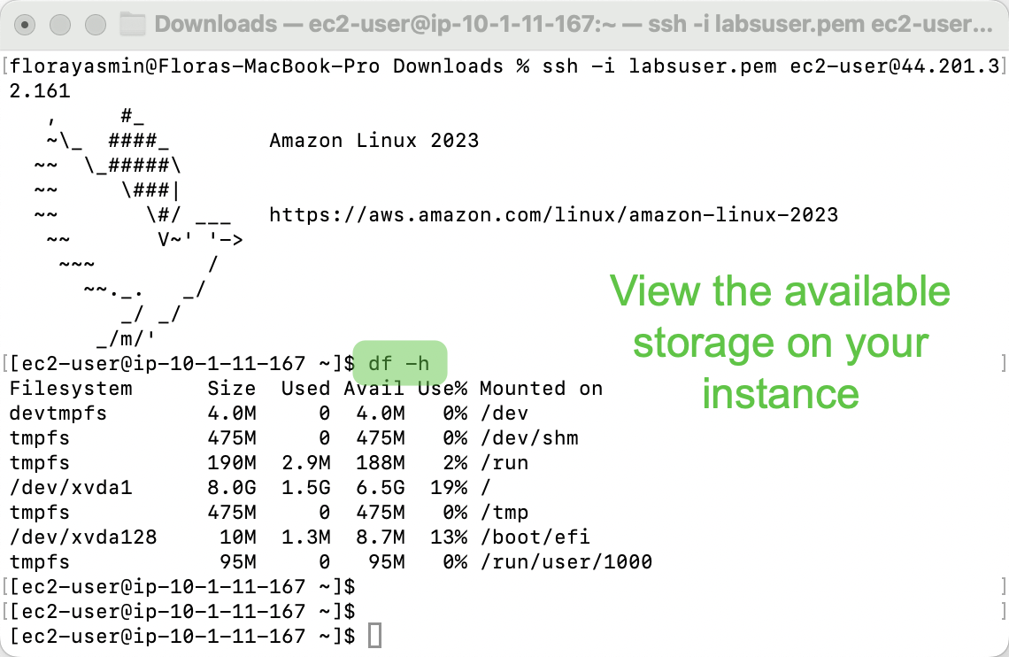

Now, enter the following commands into the terminal:

|  |  |
| --- | --- |
| sudo mkfs -t ext3 /dev/sdf | Create an ext3 file system on the volume |
| sudo mkdir /mnt/data-store | Create a directory to mount the volume |
| sudo mount /dev/sdf /mnt/data-store | Mount the new volume |
| echo "/dev/sdf /mnt/data-store ext3 defaults,noatime 1 2" | sudo tee -a /etc/fstab | Mount the Linux instance to the volume whenever the instance is started |
| cat /etc/fstab | View the configuration file |

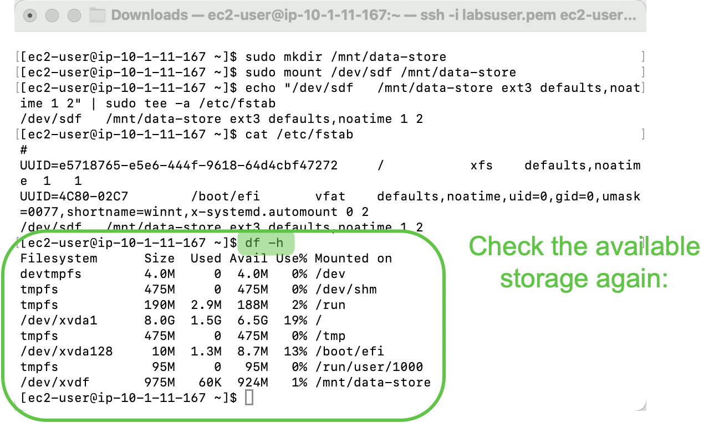

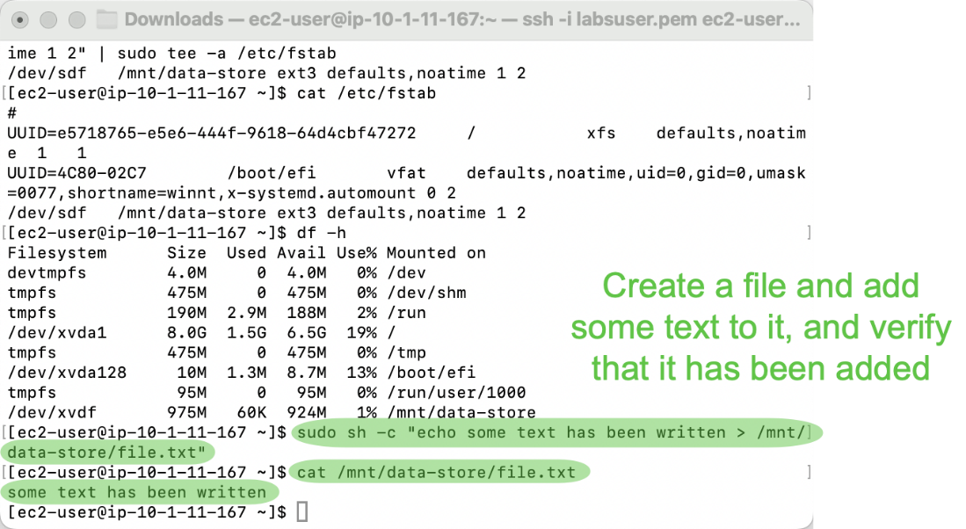

Task 5: Create an Amazon EBS Snapshot

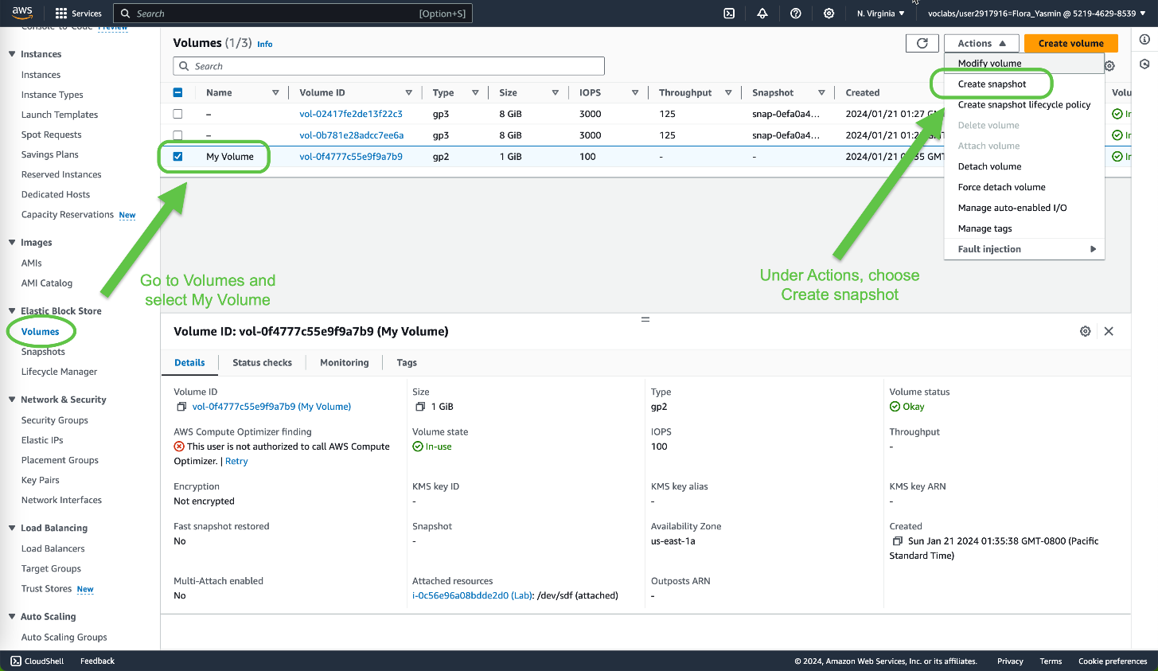

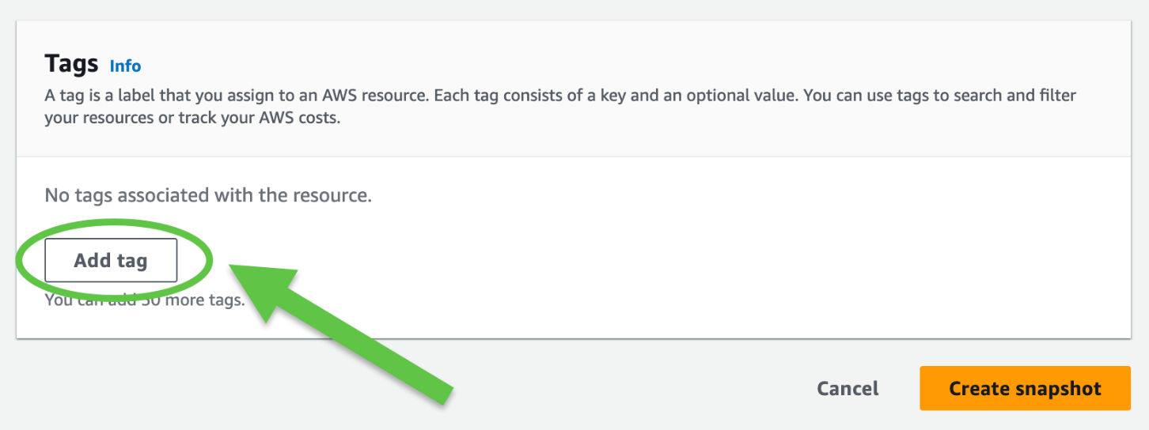

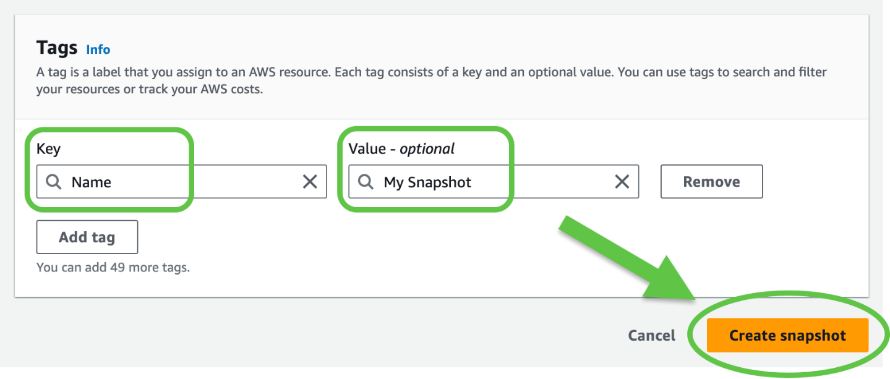

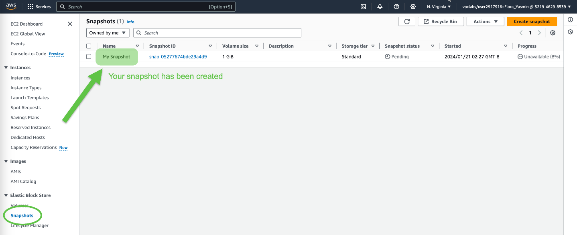

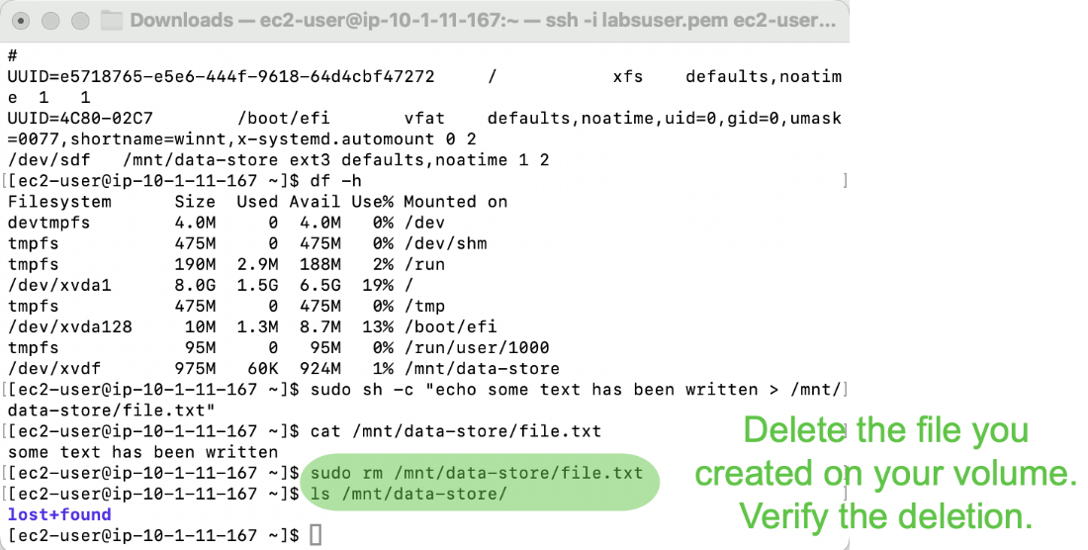

Task 6: Restore the Amazon EBS Snapshot

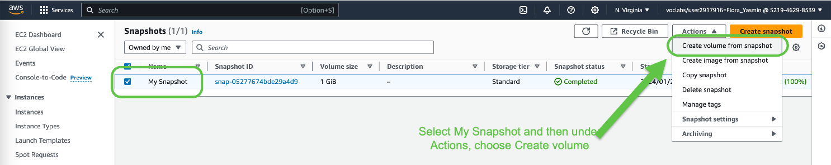

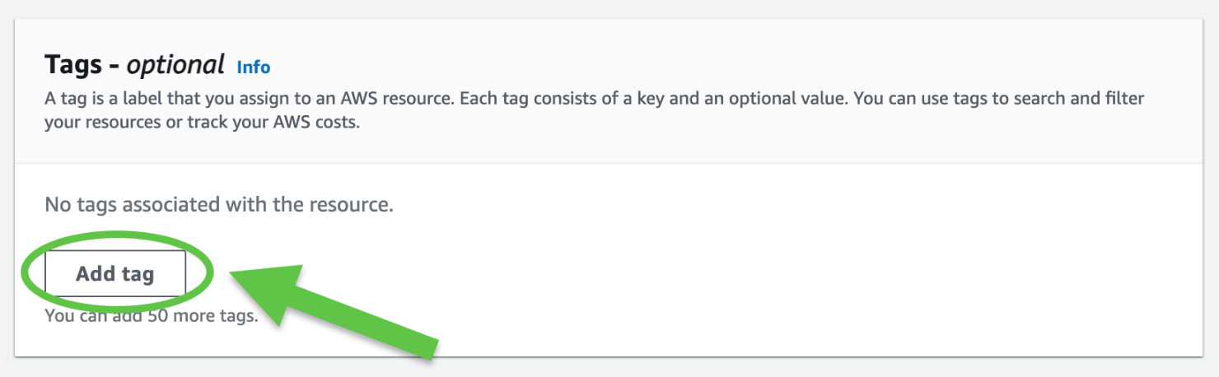

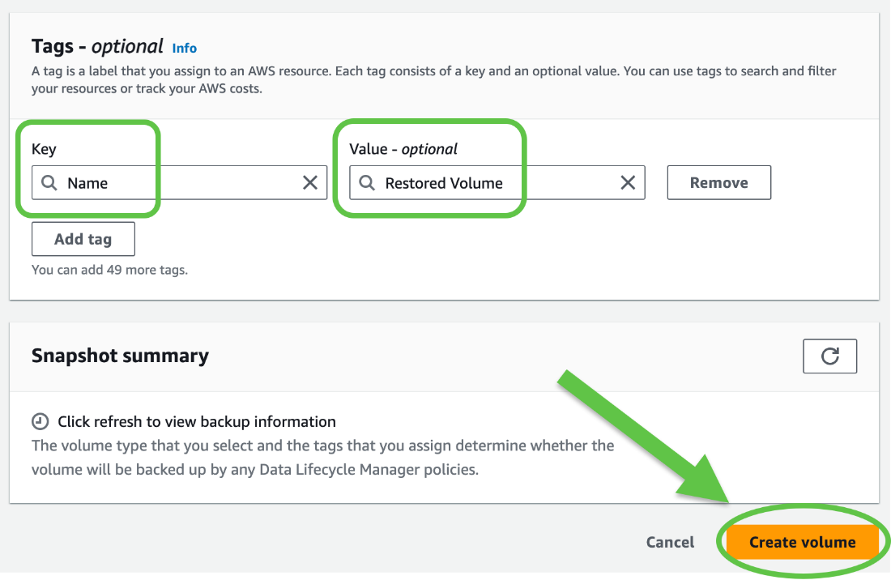

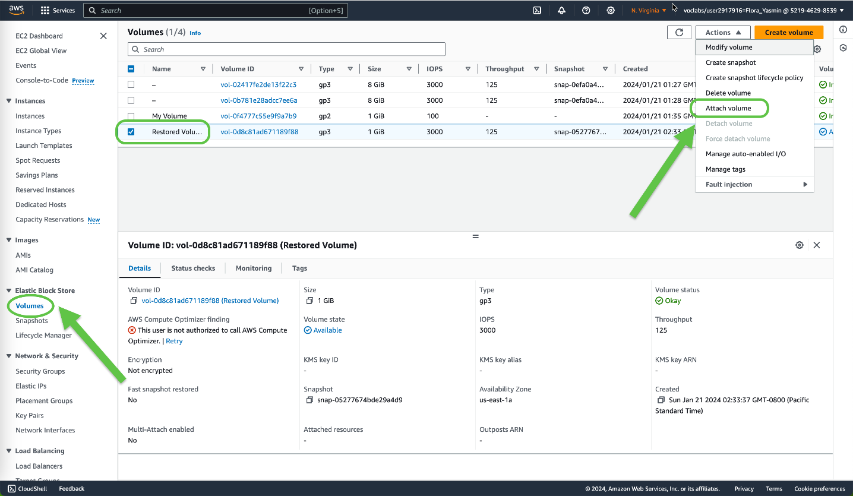

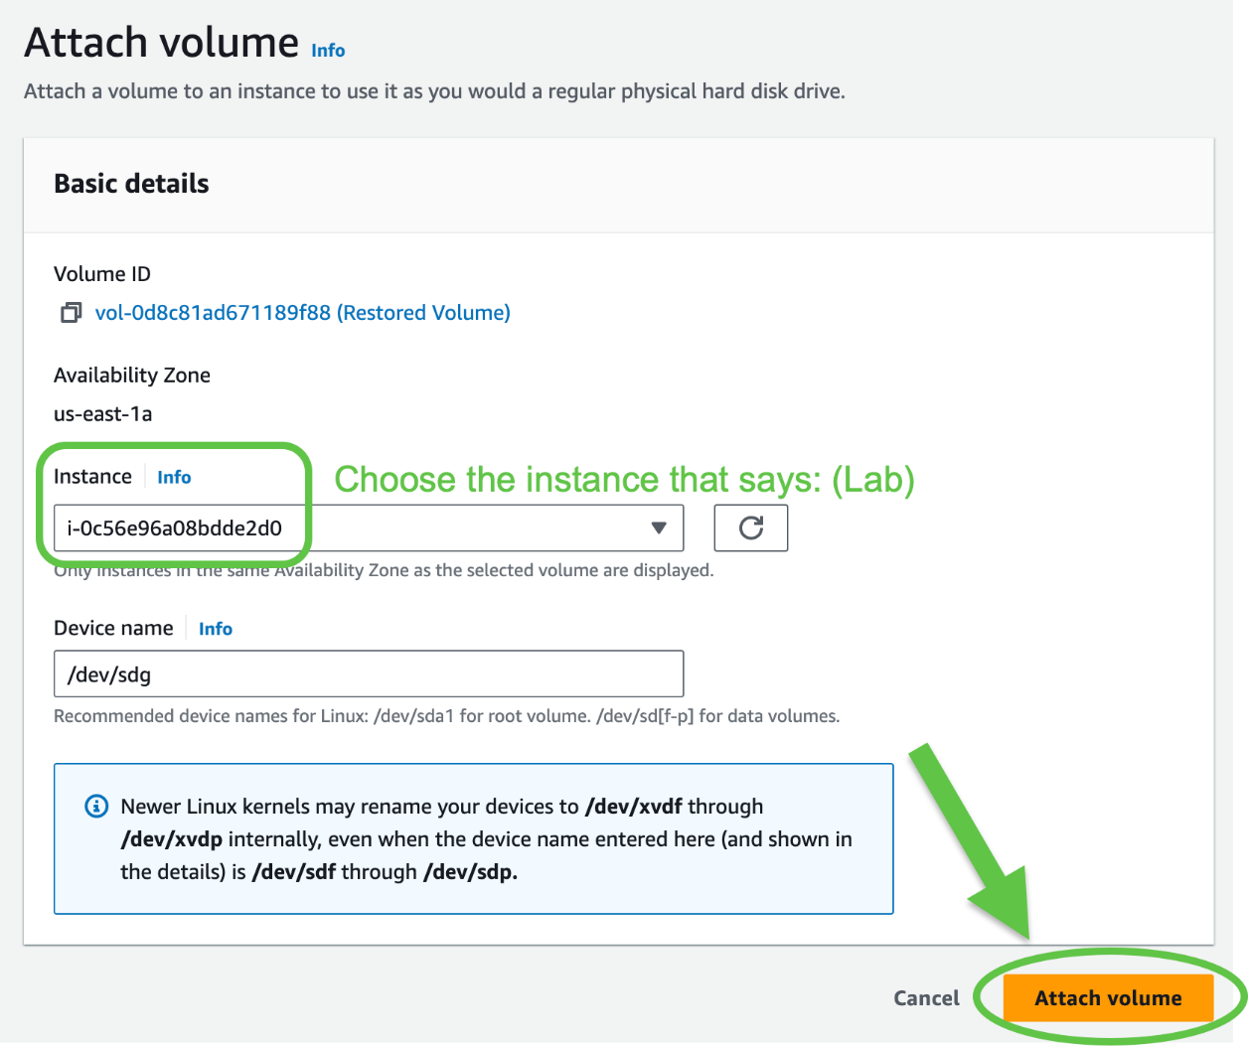

Now, enter the following commands into the terminal:

|  |  |
| --- | --- |
| sudo mkdir /mnt/data-store | Create a directory to mount the volume |
| sudo mount /dev/sdg /mnt/data-store2 | Mount the new volume |
| ls /mnt/data-store2/ | Verify the volume has the file |

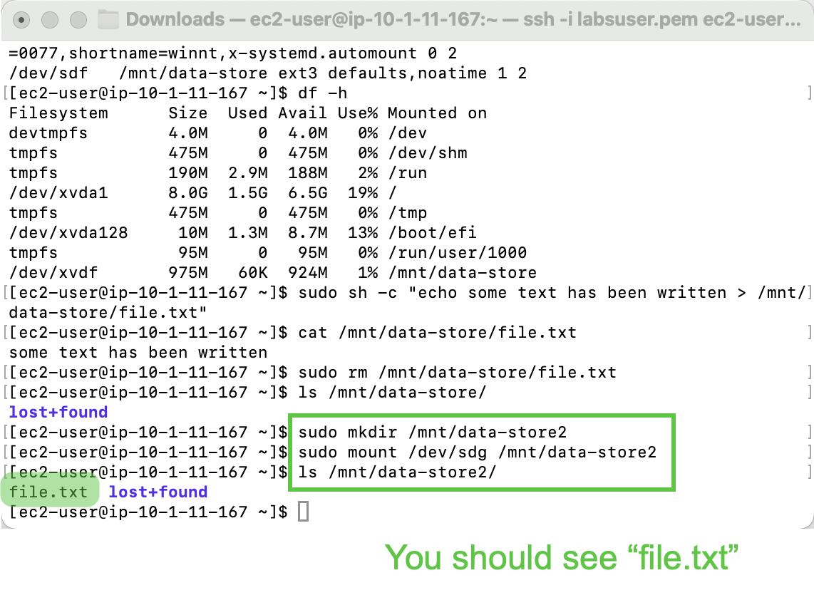

**Conclusion**

This lab demonstrates how to create Amazon EBS volumes and attach it to an EC2 instance. These processes can help us create a snapshot of the volume and model a new volume based on the previous snapshot that we can also mount to an EC2 instance later.

**Lab 5: Build a Database Center and Interact Using an App**

**Purpose**

The purpose of this lab is to reinforce the concepts behind managing an AWS database and solving relational database needs. Through completing this lab, we learn how to launch an Amazon RDS DB instance with high availability, configure the instance to permit connections from the web server, and open a web application and interact with your database.

**Background Information**

This lab utilizes the Amazon Relational Database Service (Amazon RDS), a service that makes it easier to set up, operate, and scale a relational database in the cloud. Amazon RDS is cost-efficient and sizable while being able to manage time-consuming database administration tasks. Using this service allows AWS users to be efficient as well as it allows them to focus on their applications and business. It is also available to use in six familiar database engines: Amazon Aurora, Oracle, Microsoft SQL Server, PostgreSQL, MySQL, and MariaDB. Amazon Relational Database Service makes database administrative tasks easier to manage, without the need of constantly maintaining software on your own. Using Amazon RDS Multi-AZ deployments, users are also able to achieve high availability. Overall, through using Amazon RDS, users get the proven to be best security practices that are available in the cloud.

The way Amazon RDS works is shown in the diagram below:

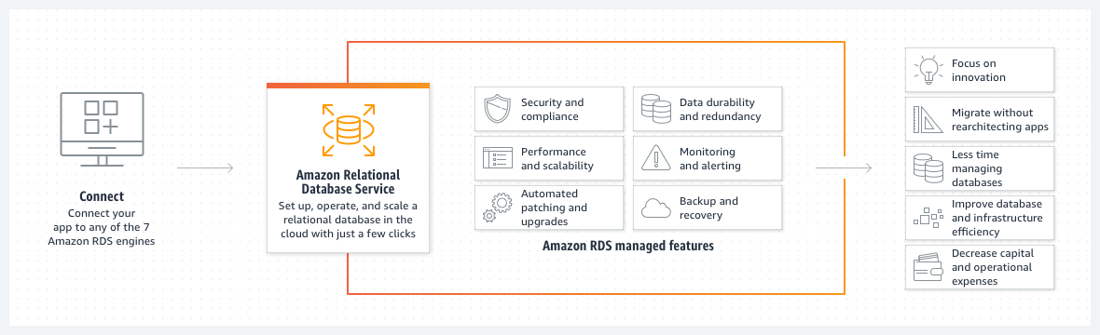

Essentially, once a user connects their app to any Amazon RDS engine, they can use the Relational Database Service to set up, operate, and scale their database within the cloud, utilizing Amazon Web Services. Amazon RDS’s benefits in this scenario include its security, scalability, data durability, redundancy, alert system, backup and recovery, and automated upgrades and a patch system. Using RDS results in more efficient management of databases and infrastructure, while allowing the company to decrease operational costs and have a greater focus on the innovation itself.

Amazon RDS can be used in many cases, such as building web and mobile applications. RDS can support many apps with its high availability, throughput, and storage scalability. The pay-as-you-go pricing model also goes well with any application’s usage. Again, Amazon RDS also helps users focus on innovating and building their apps while managing the databases itself, since database management can be consuming, complex, and expensive.

**Lab Procedures**

Task 1: Create a Security Group for the RDS DB Instance

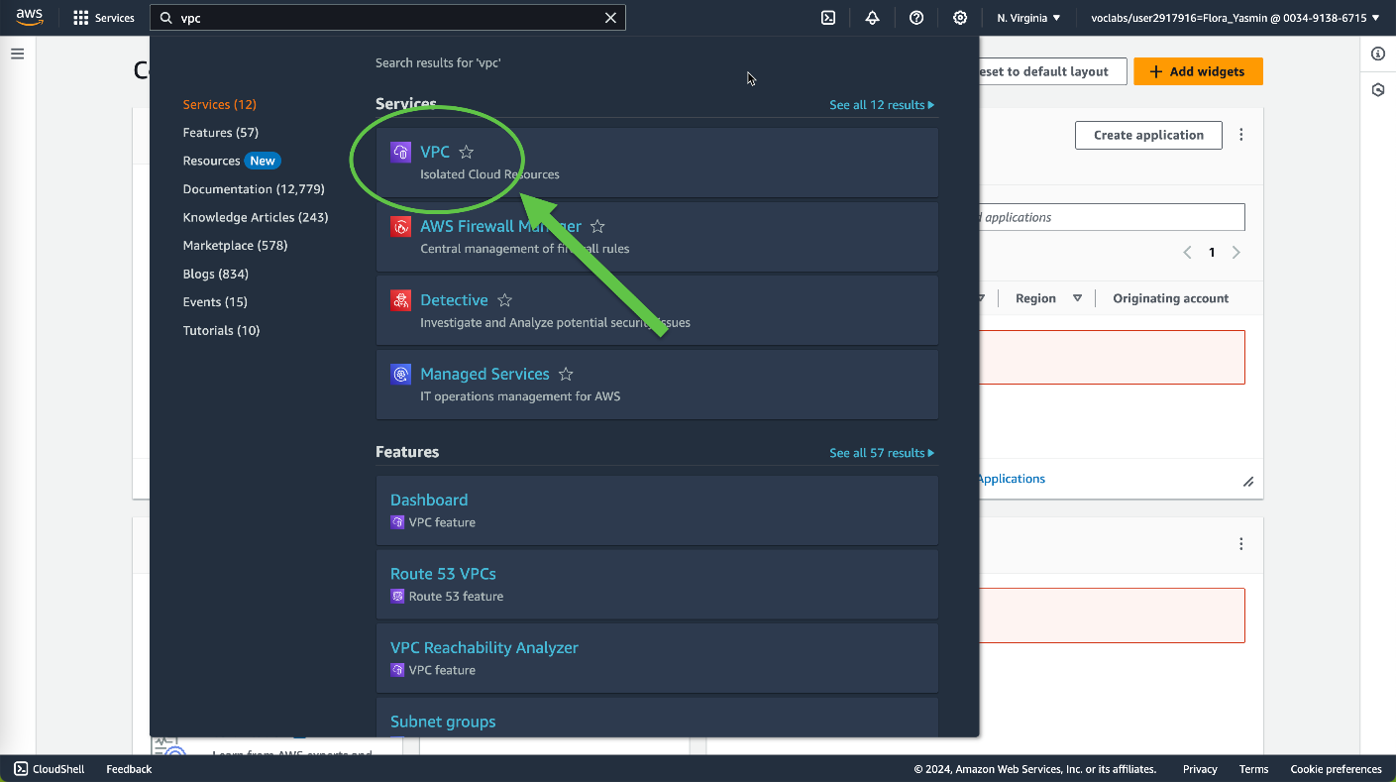

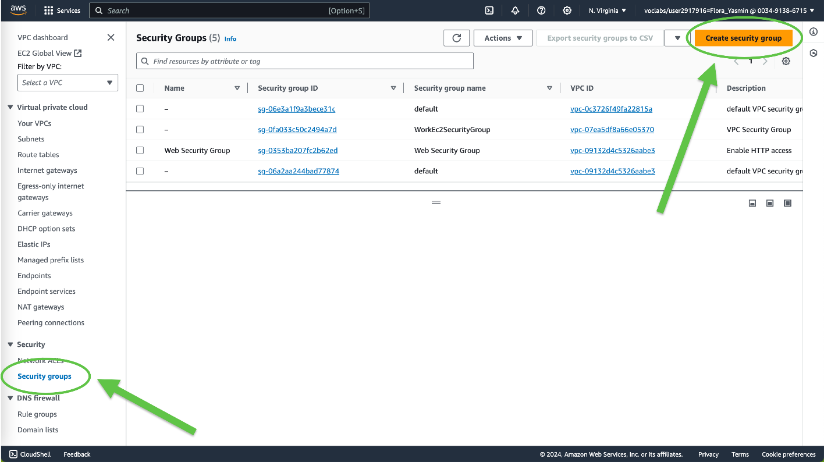

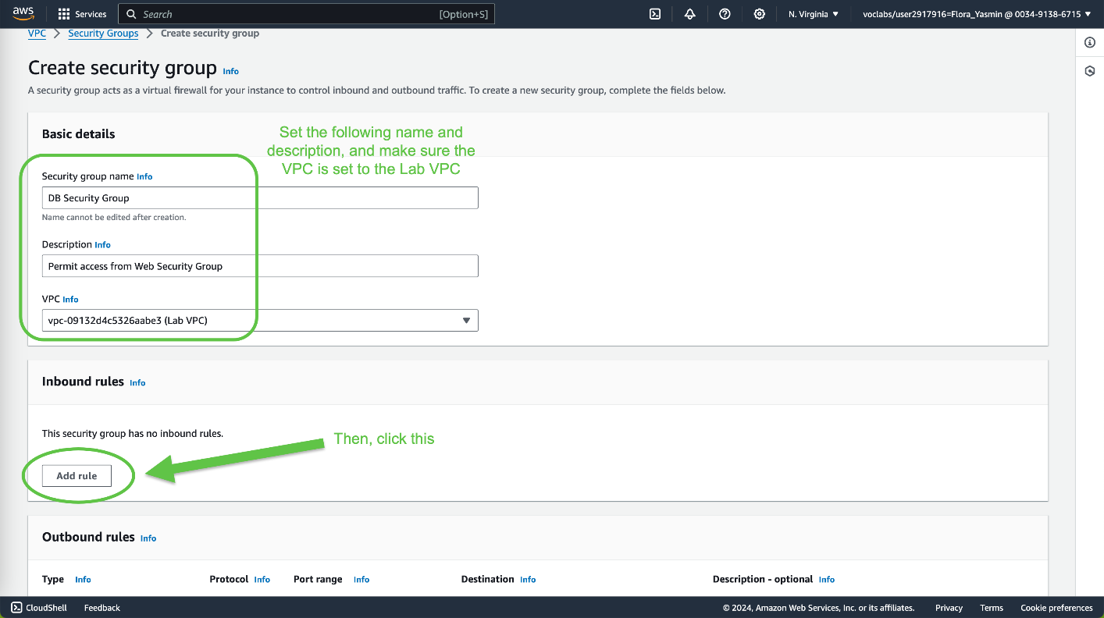

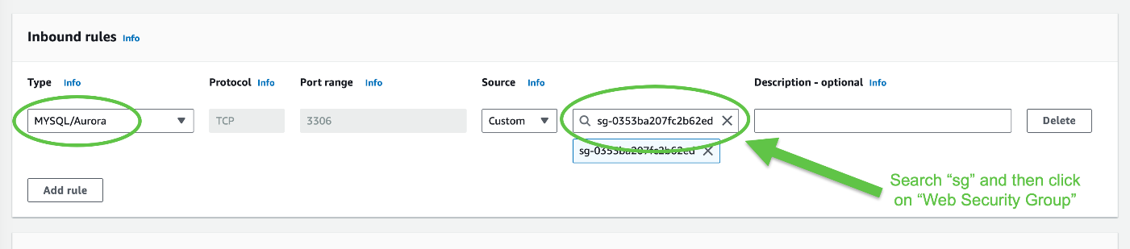

This configures the Database security group to permit inbound traffic on port 3306 from any EC2 instance that is associated with the *Web Security Group*.



Task 2: Create a DB Subnet Group

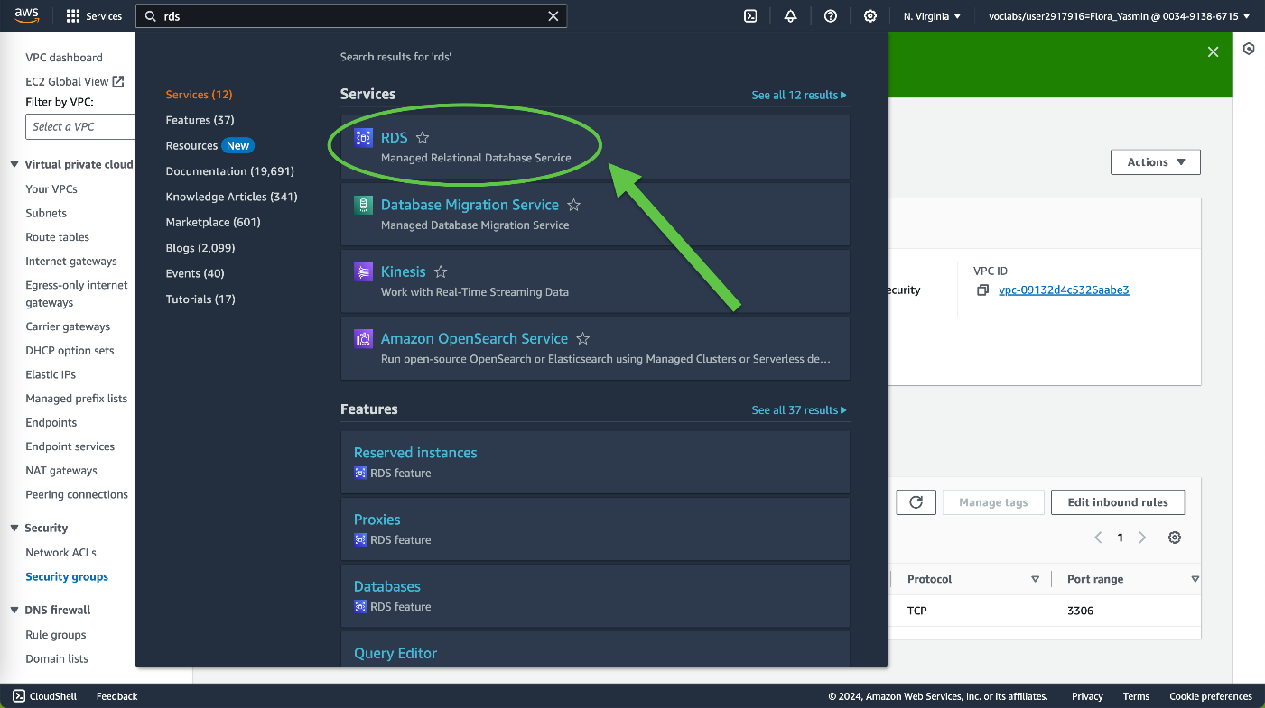

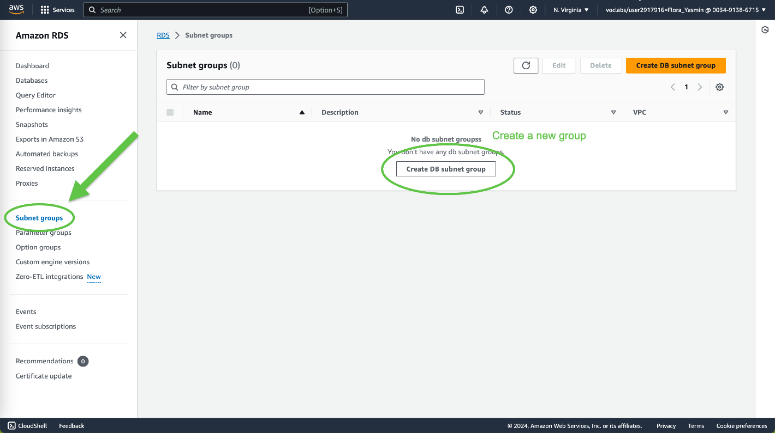

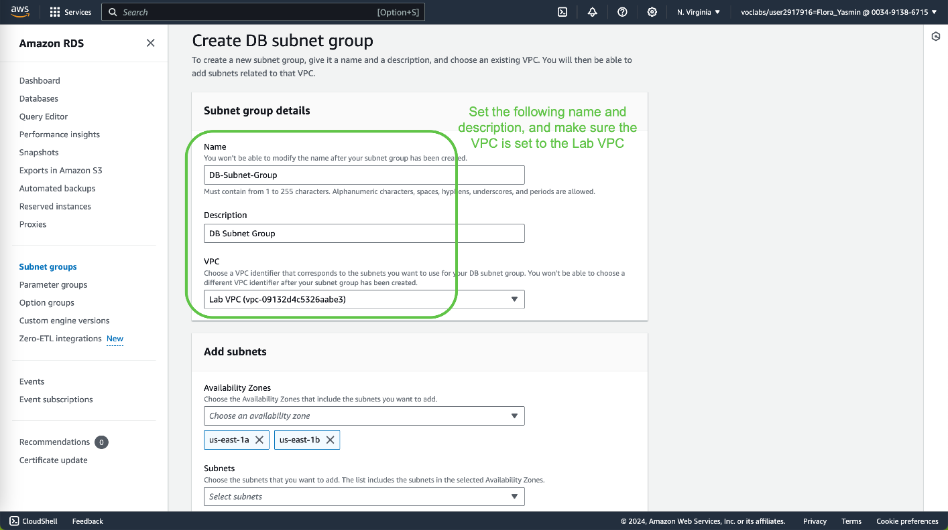

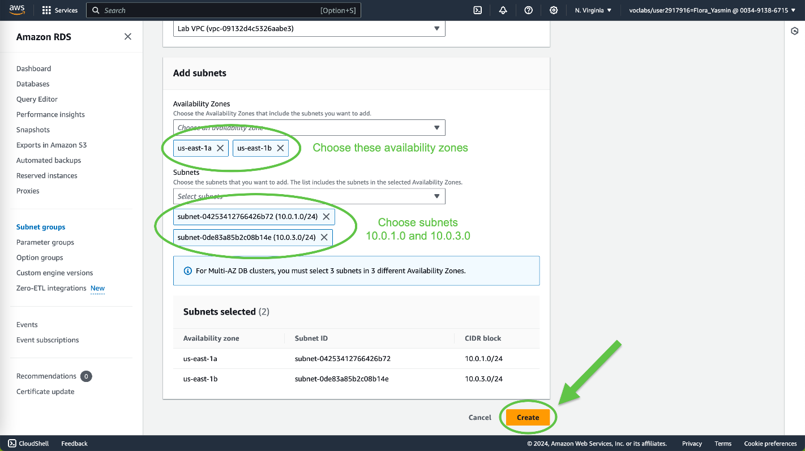

Task 3: Create an Amazon RDS DB Instance

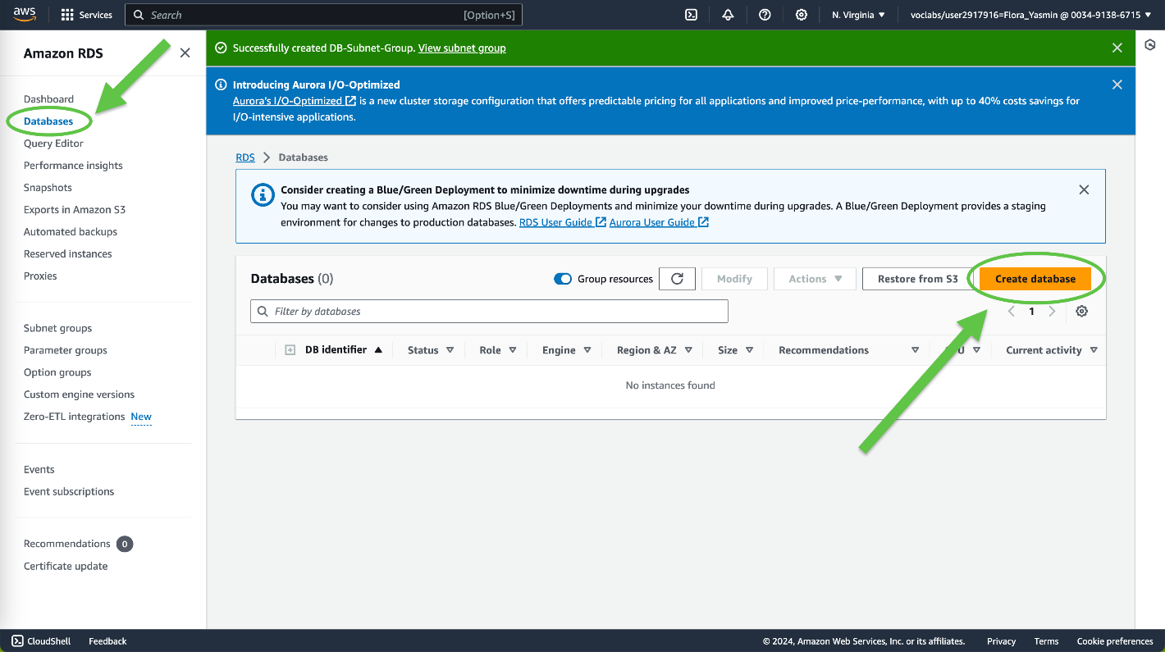

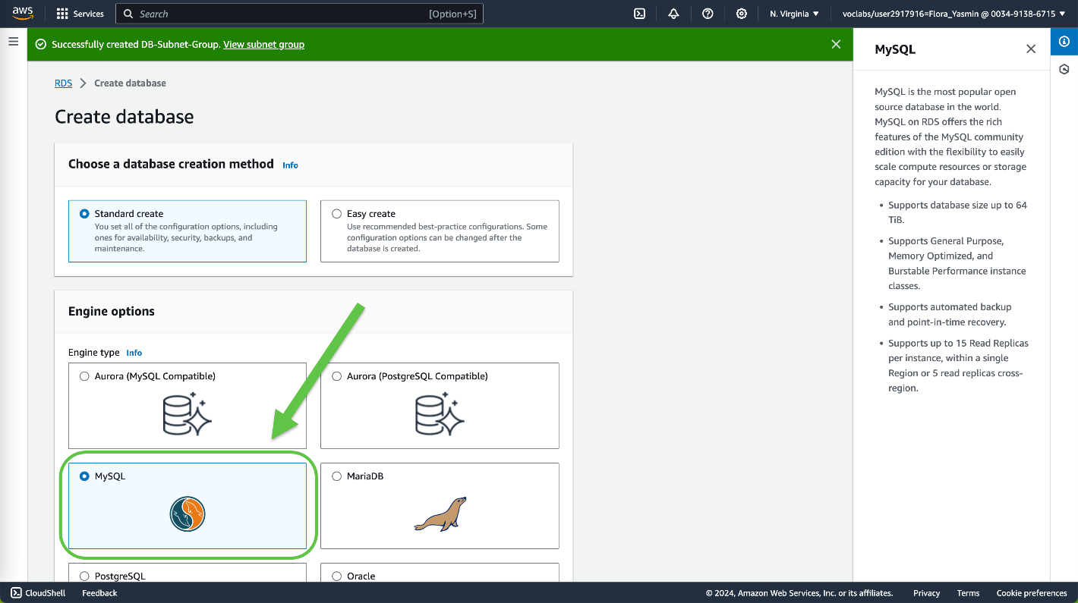

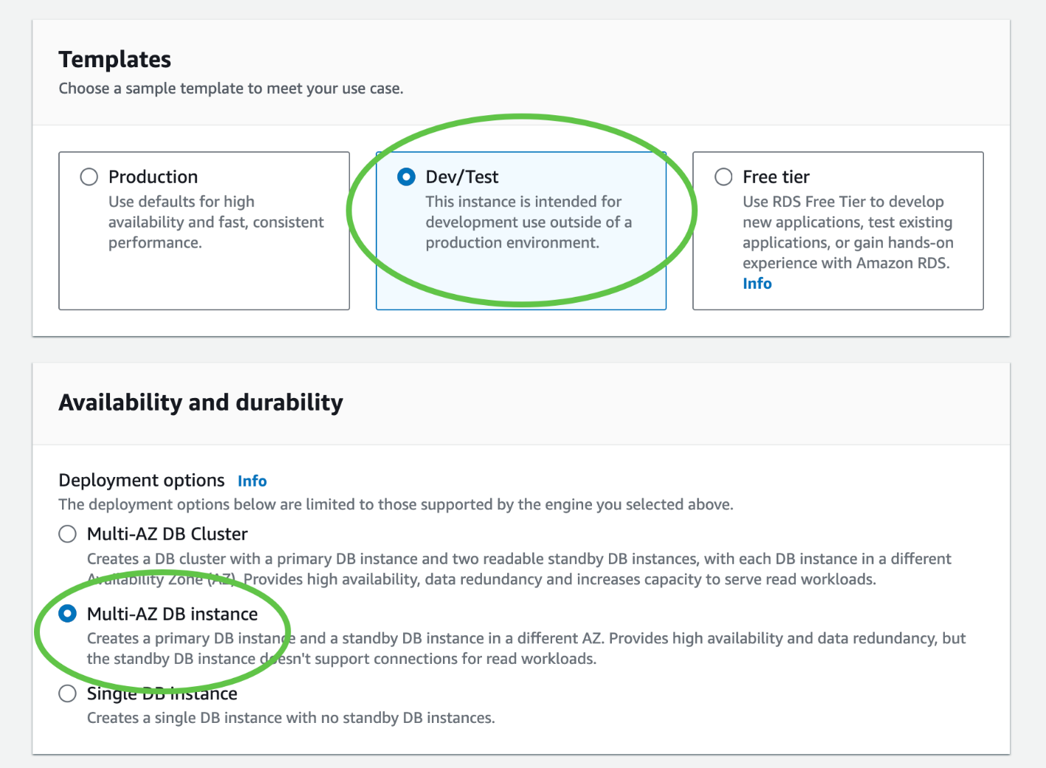

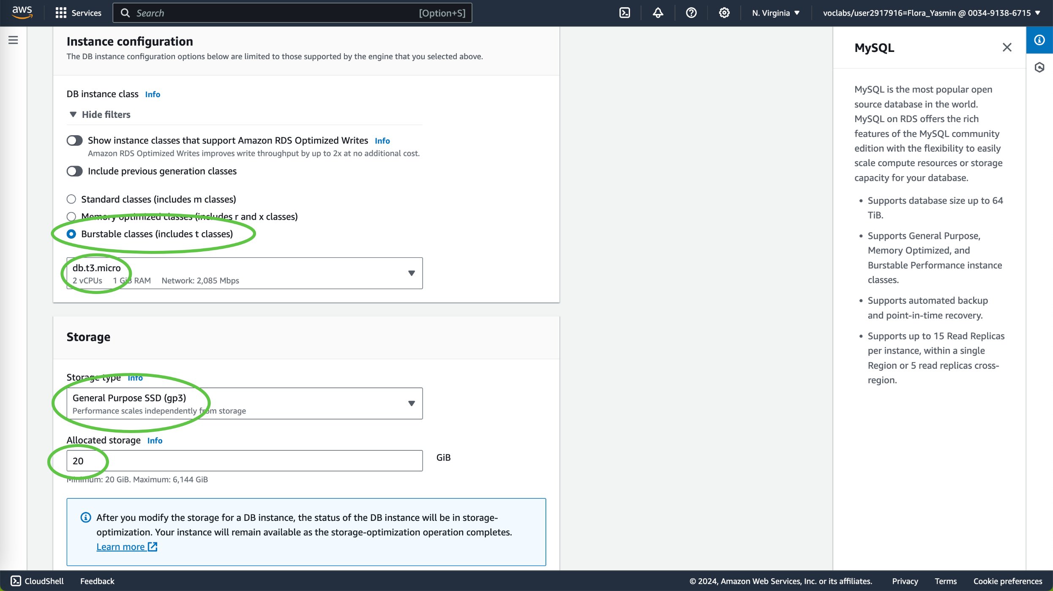

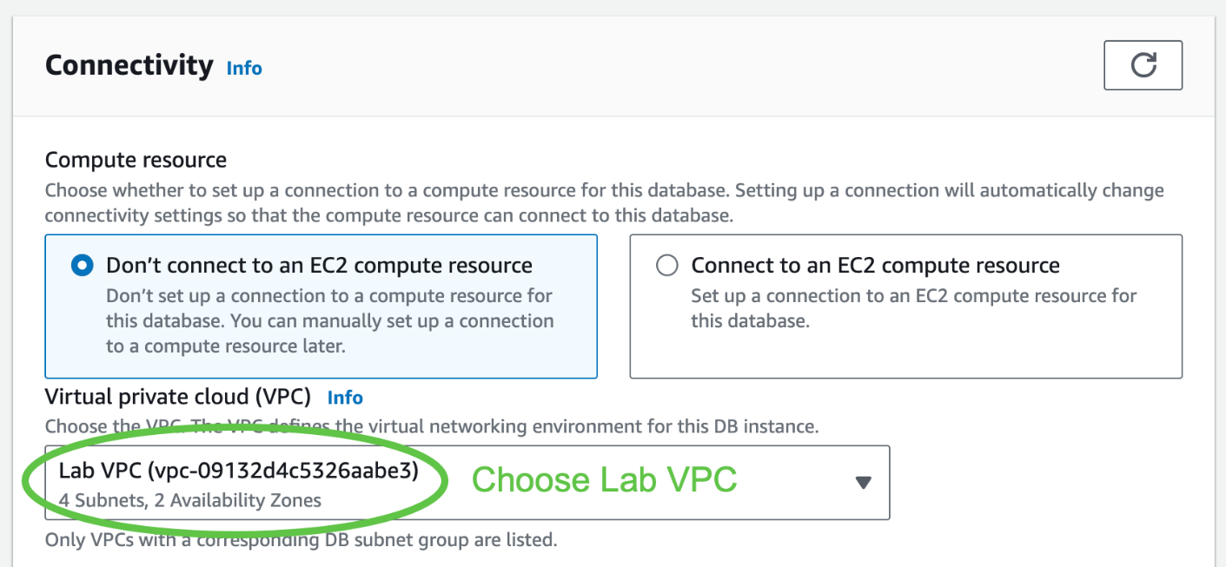

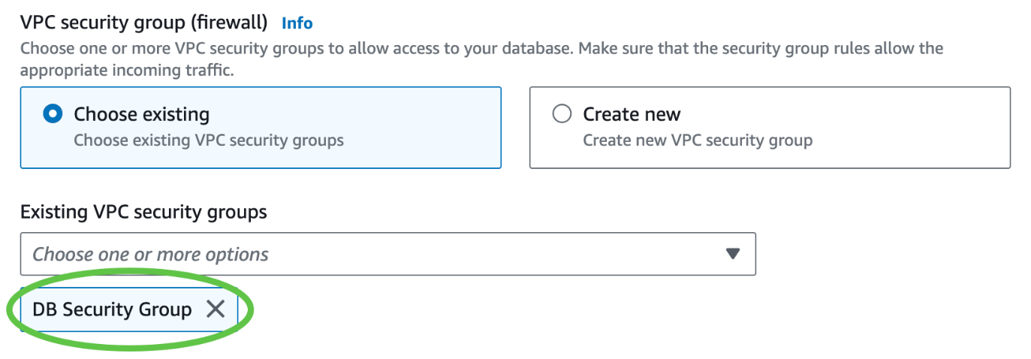

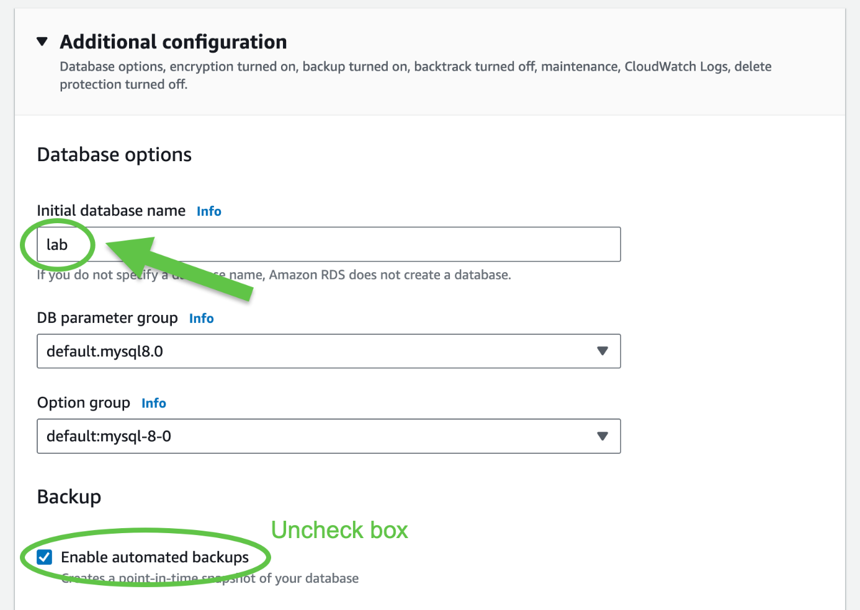

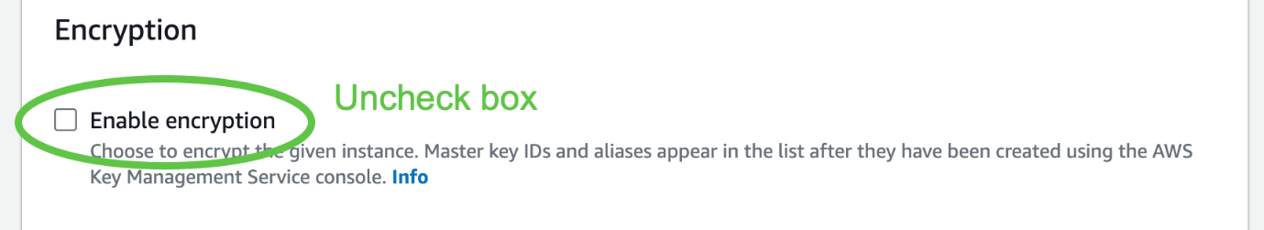

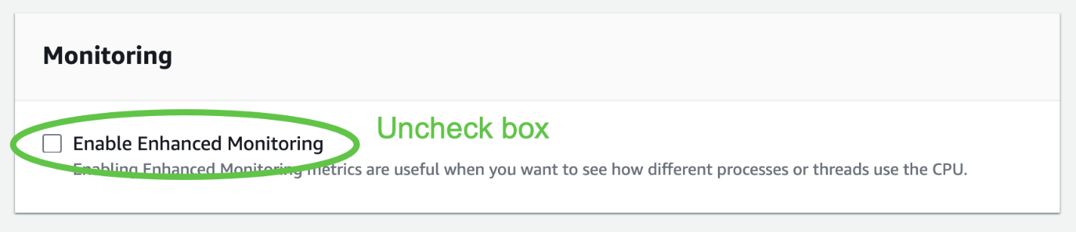



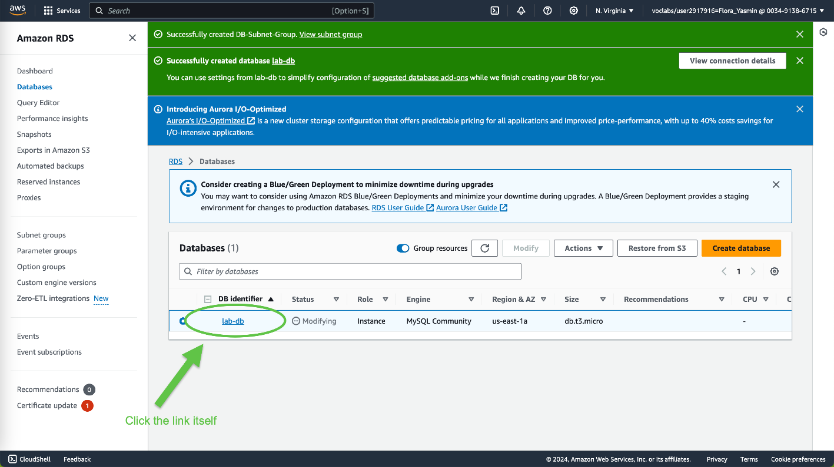

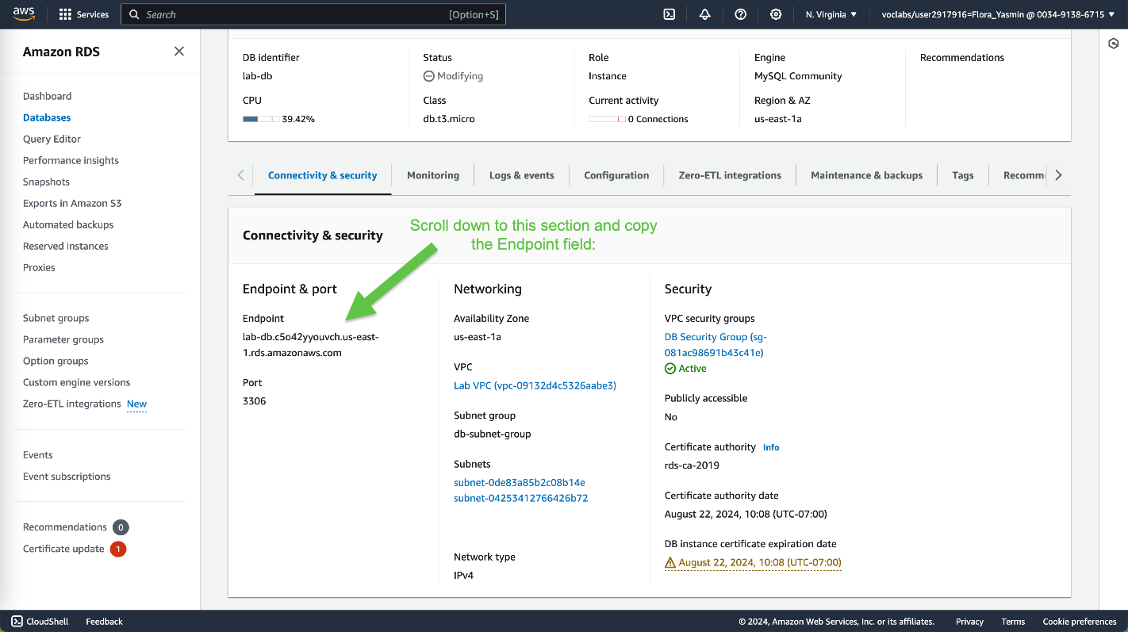

Paste it into a text editor:

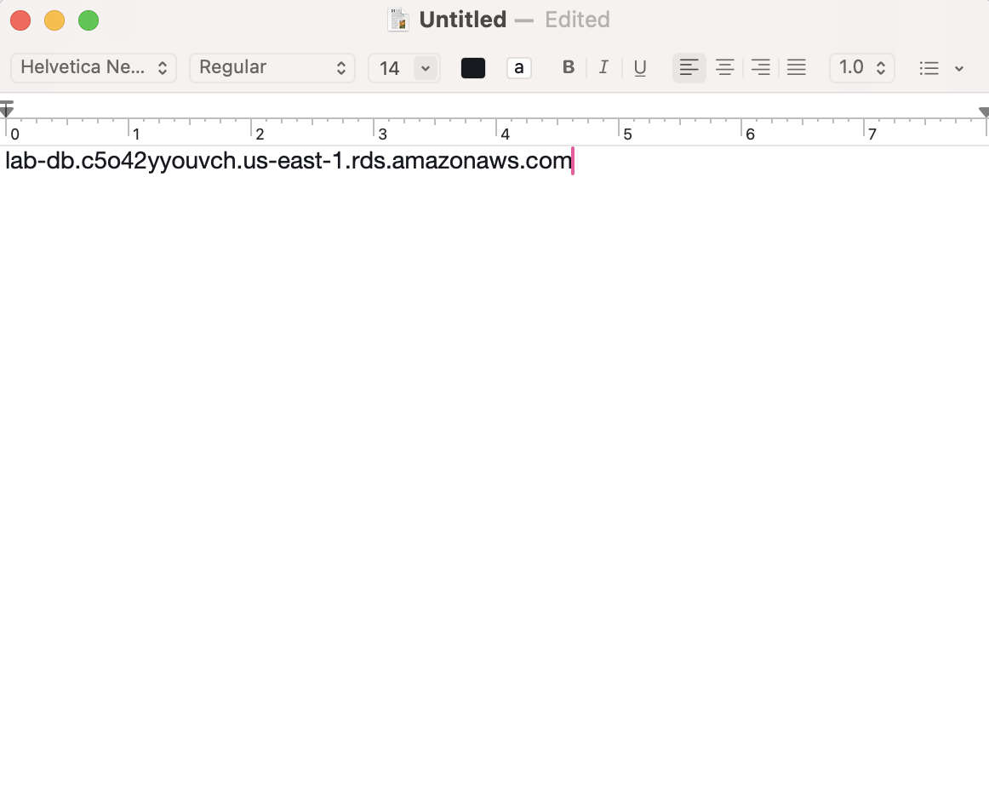

Task 4: Interact with Your Database

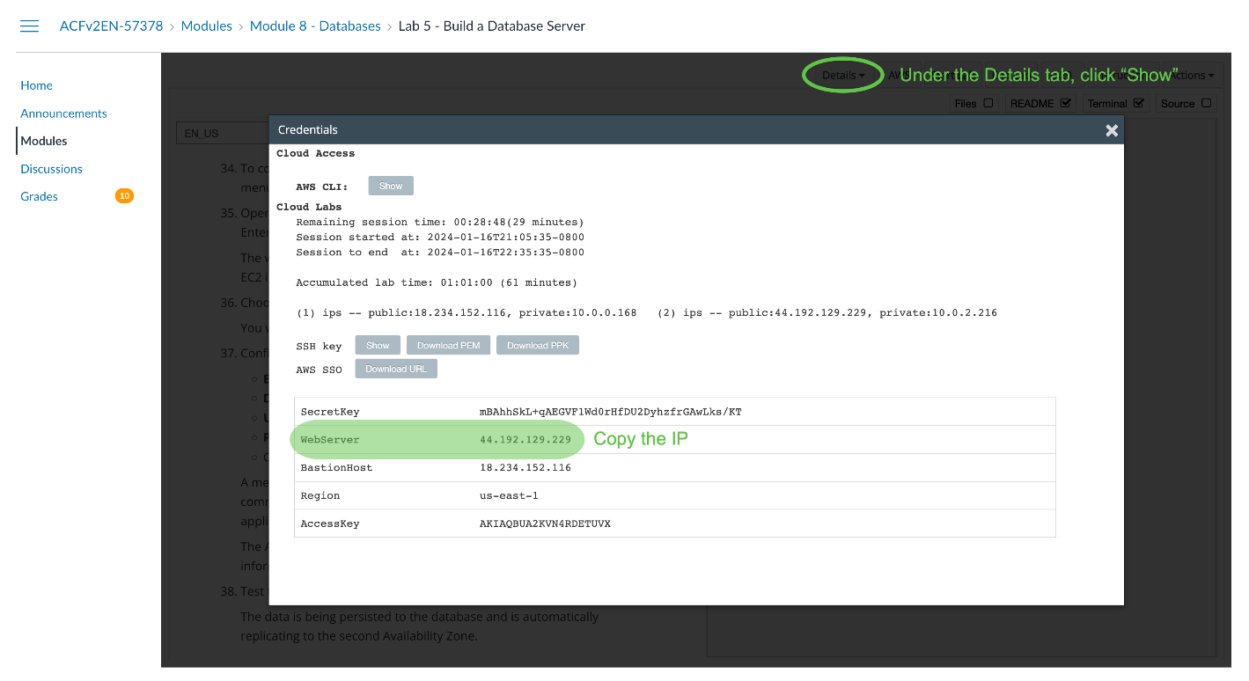

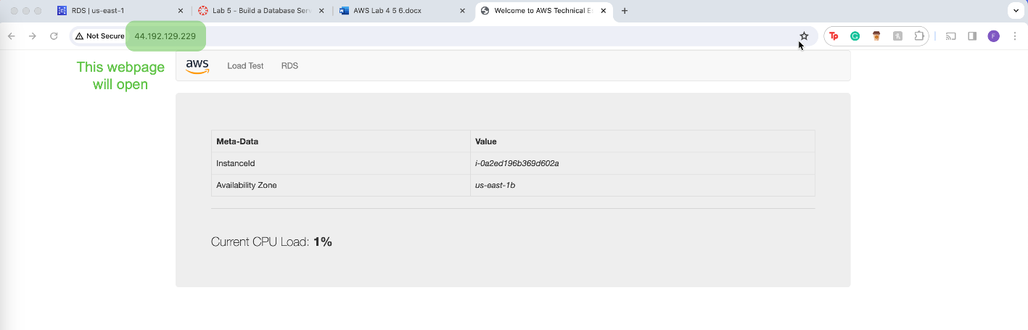

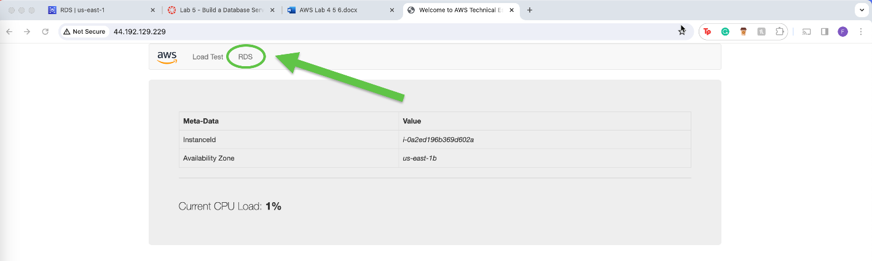

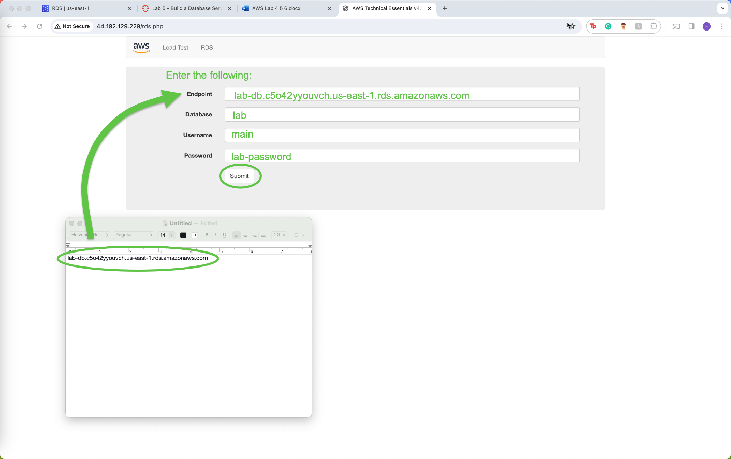

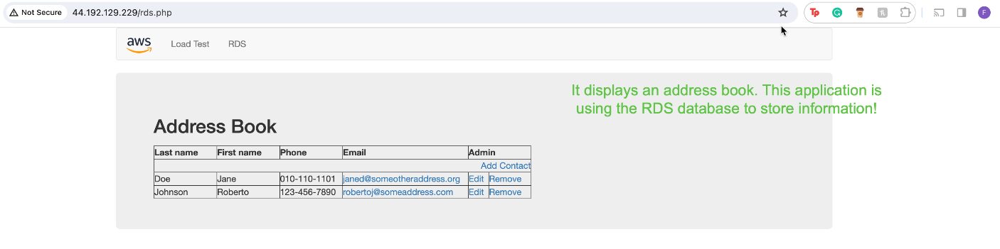

**Conclusion**

This lab showed how to launch an Amazon RDS database instance with high availability and to configure the instance with permissions to connect to the web server. Completing this lab also helps gain hands on experience with opening a web application and interacting with the database.

**Lab 6: Scale and Load Balance Your Architecture**

**Purpose**

This lab gives an overview of using the Elastic Load Balancing (ELB) feature and Auto Scaling services to load balance and automatically scale infrastructure. This lab walks through creating an Amazon Machine Image (AMI) from an instance, as well as creating a load balancer, a launch template, and an Auto Scaling group.

**Background Information**

As the name suggests, this lab primarily focuses on Elastic Load Balancing and Auto Scaling. Elastic Load Balancing is a feature that allows users to automatically distribute incoming traffic from applications across multiple Amazon EC2 instances. It also enables fault tolerance among applications by providing load balancing capacity in routing traffic from applications.

Elastic Load Balancing can be available in 3 different types: Application Load Balancer, Network Load Balancer, and Classic Load Balancer. The Application Load Balancer focuses on load balancing HTTP and HTTPS traffic and routes this traffic when requested by targets and is operated at the application (layer 7) layer of the OSI model. On the other hand, the Networking Load Balancer, load balances TCP, UDP, and TLS traffic and routes traffic based off of IP protocol data it receives. The Network Load Balancer has the ability to perform at extreme capacity while maintaining low latency. This load balancer operates in the transport layer, or layer 4 in the OSI model. Lastly, the Classic Load Balancer is from the previous generation and is a mix of both the Application and Network Load Balancer, as it handles HTTP, HTTPS, TCP, and SSL traffic. As this one is a mix, it operates in both the transport layer and the application layer.

Auto Scaling allows users to scale Amazon EC2 automatically according to conditions defined by the user and maintain application availability. This can be used to ensure the right amount of EC2 instances are being run and can also be used to increase the number of running EC2 instances during demand spikes to maintain performance and decrease capacity while reducing costs. Auto Scaling works well with both applications that rarely experience demand spikes and applications that experience variabilities often when used.

**Lab Procedures**

Task 1: Create an AMI for Auto Scaling

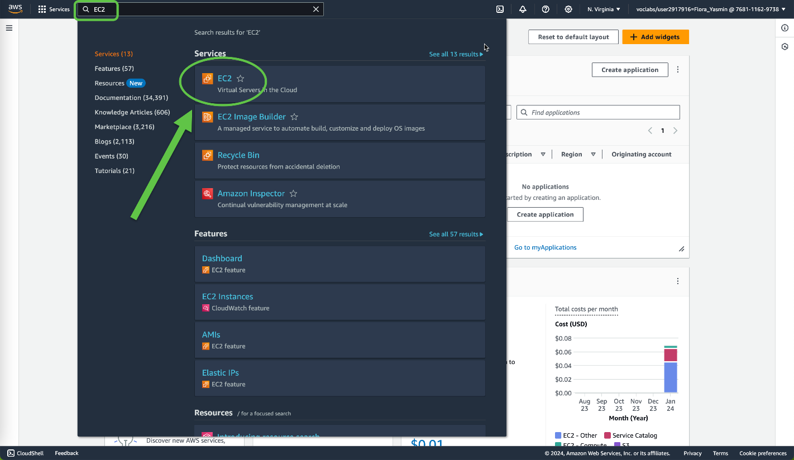

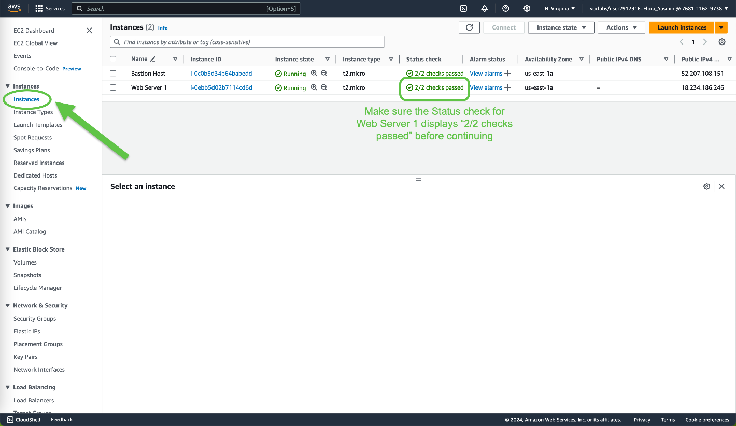

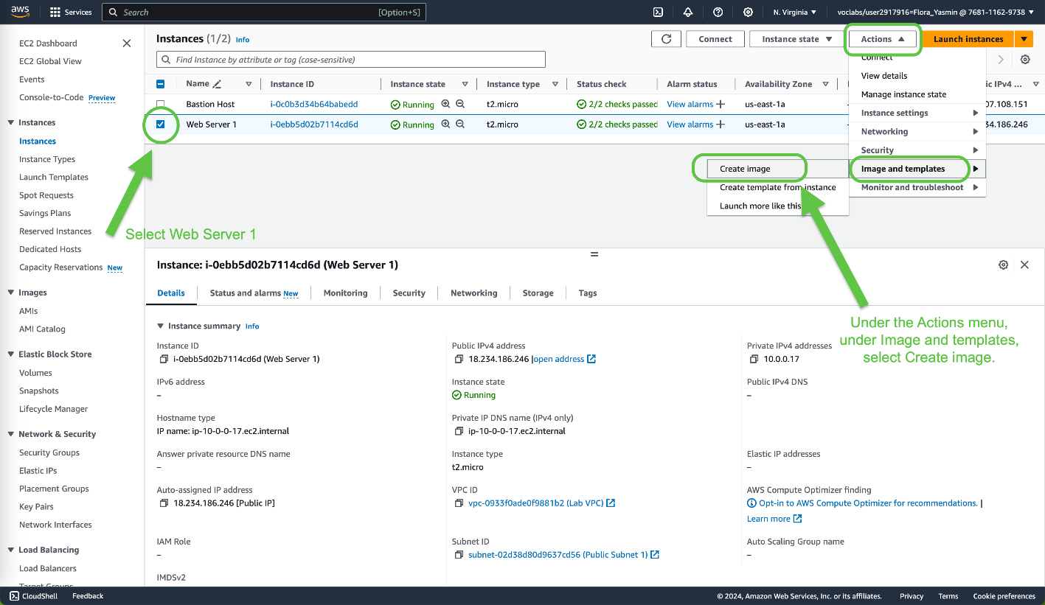

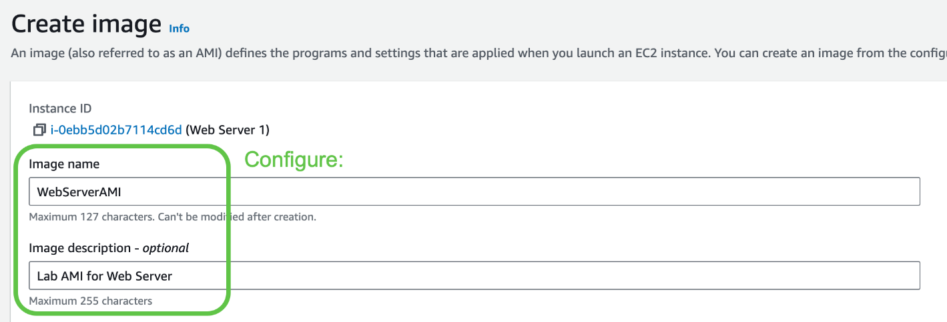

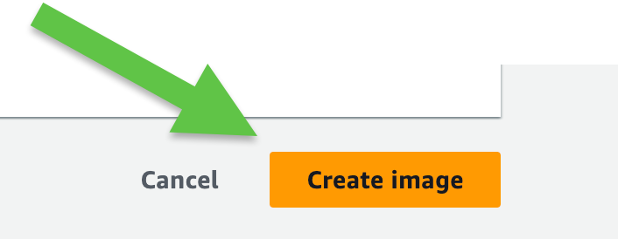

A confirmation banner will show:



Task 2: Create a Load Balancer

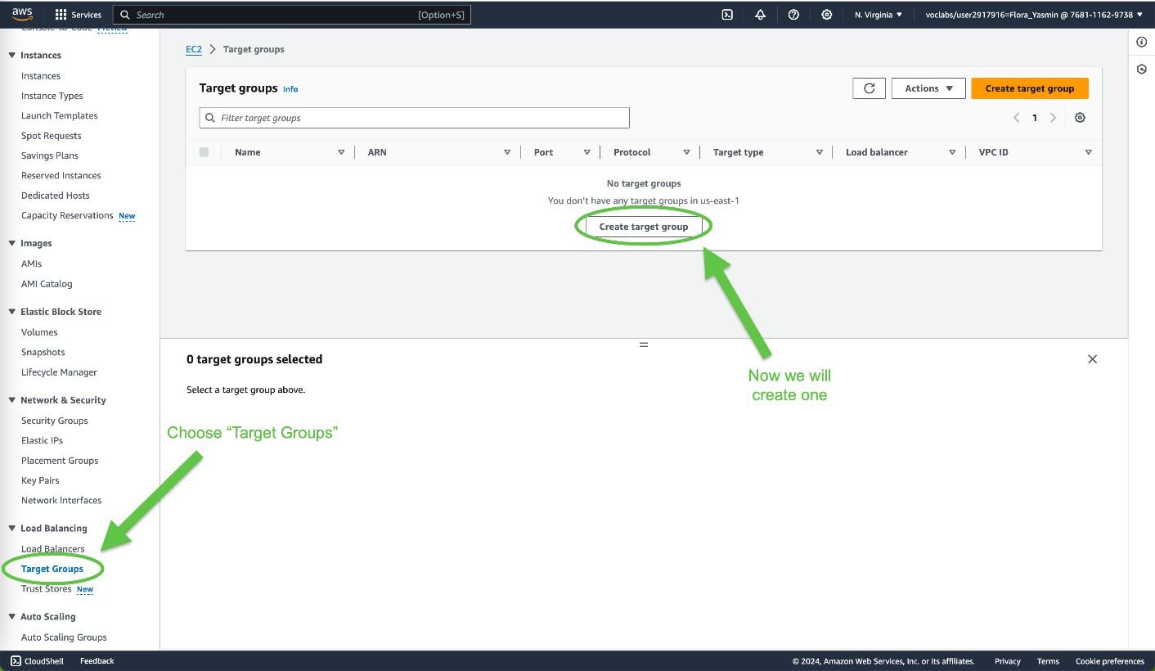

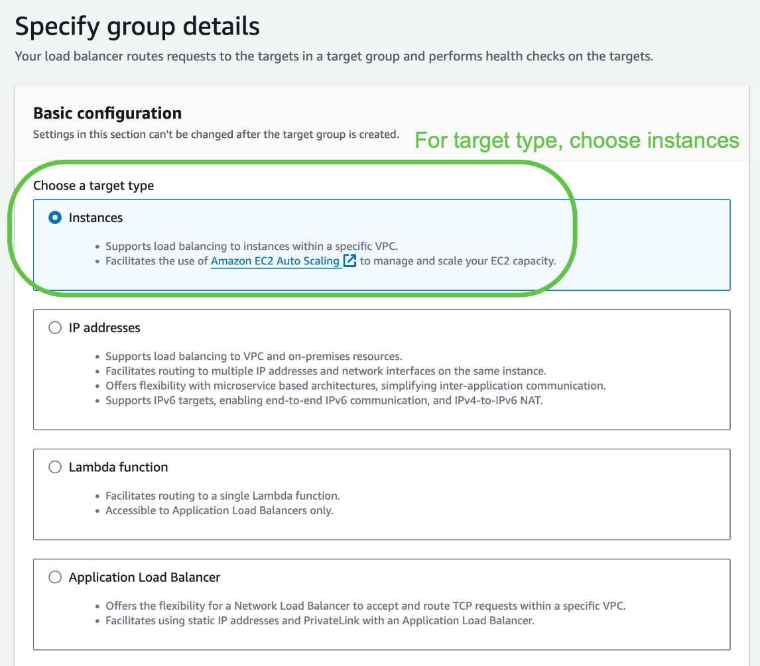

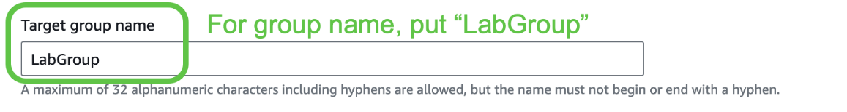

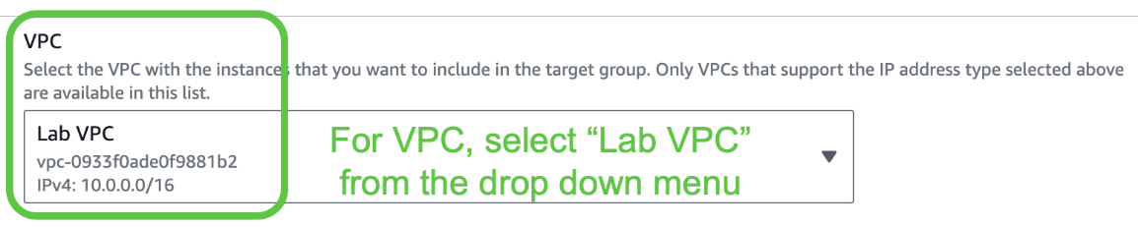



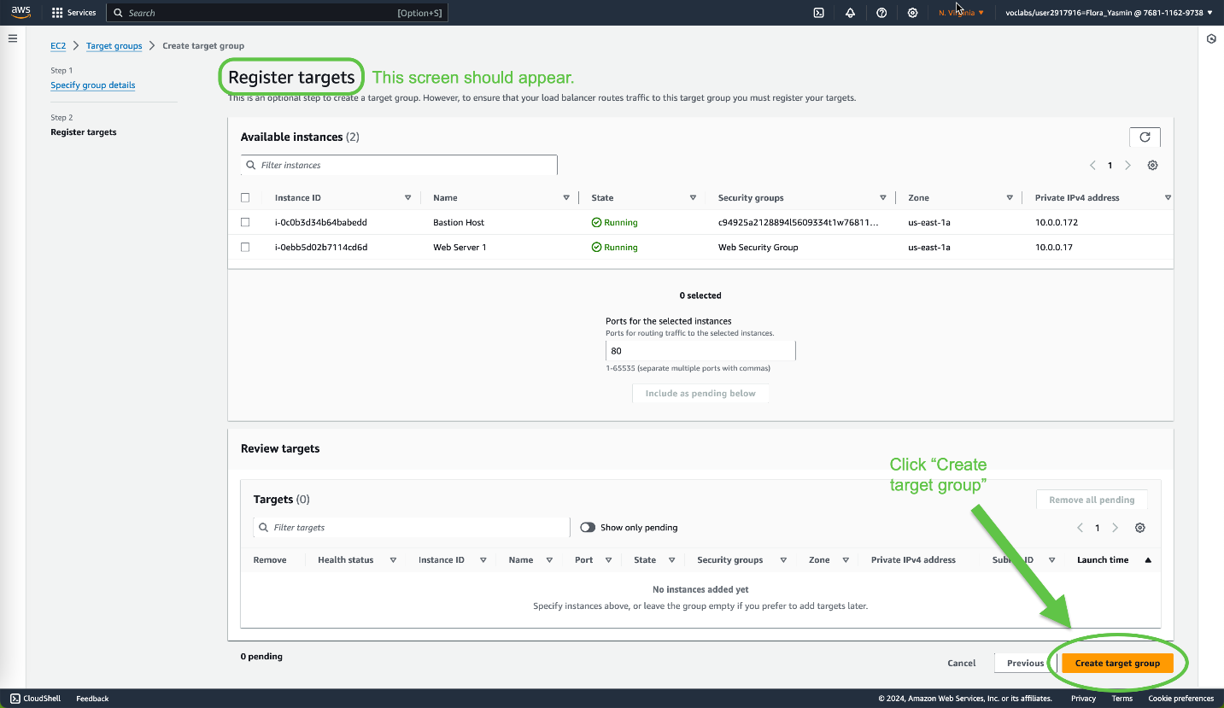

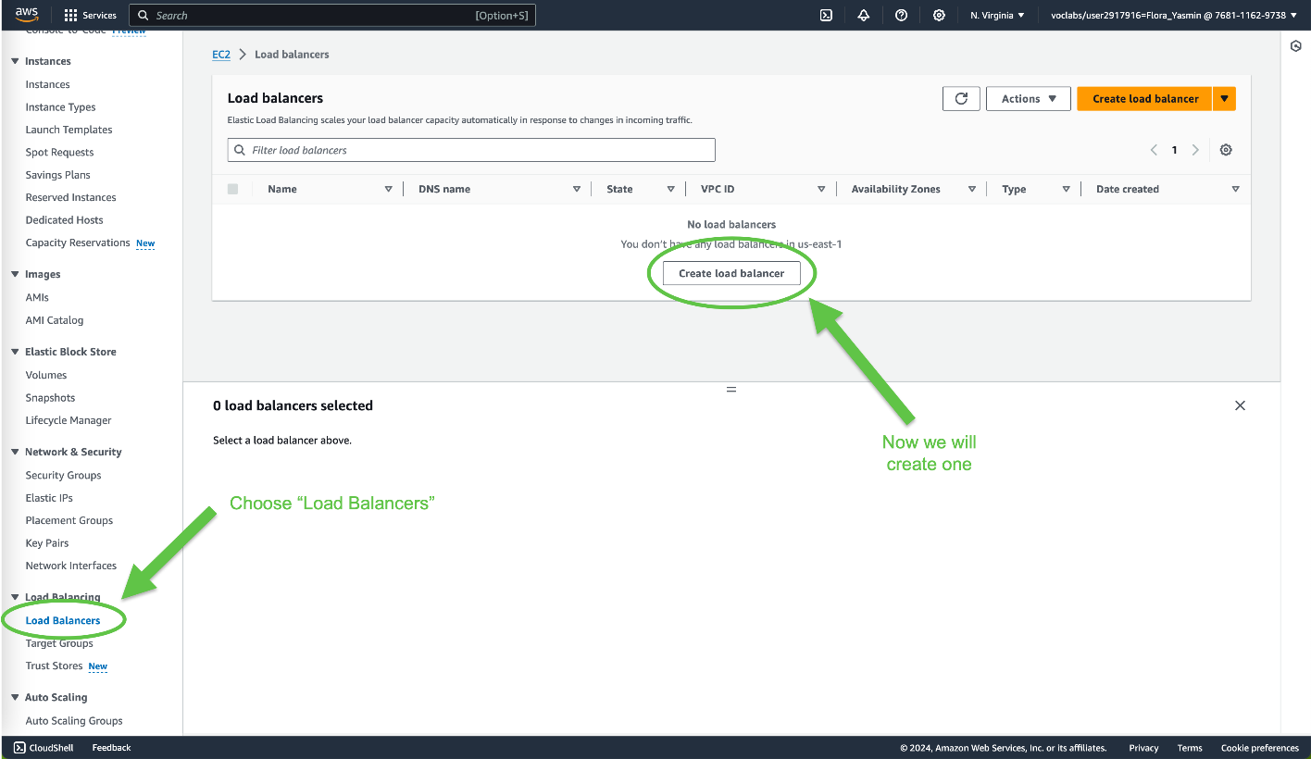

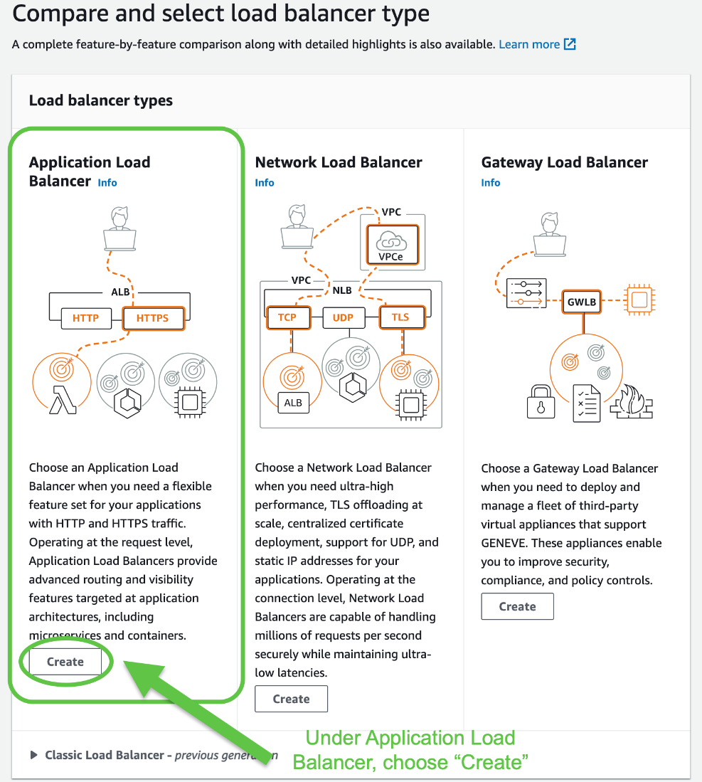

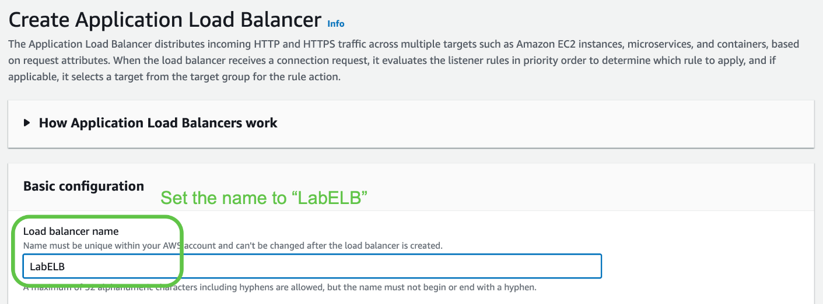

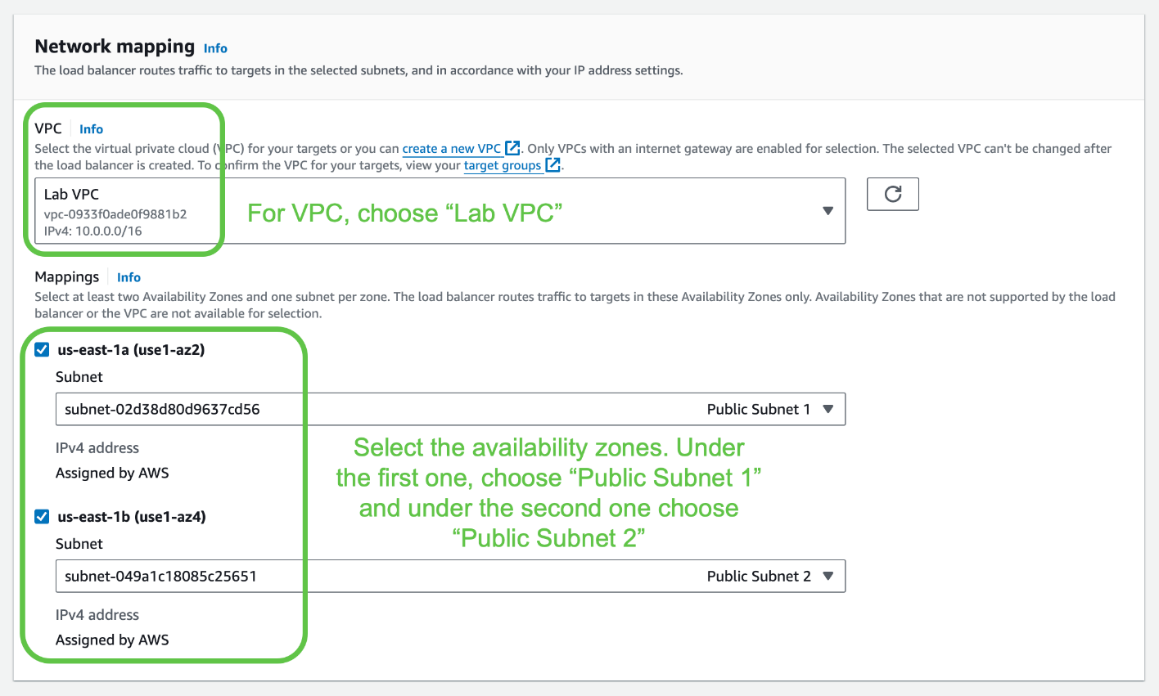

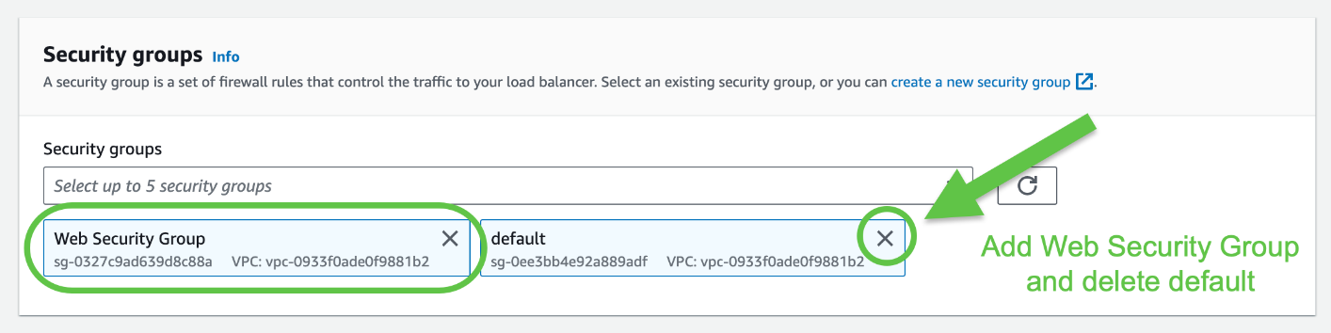

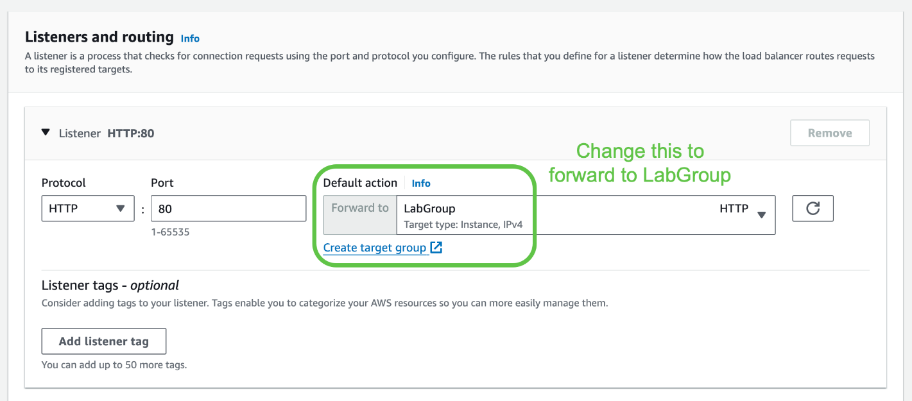



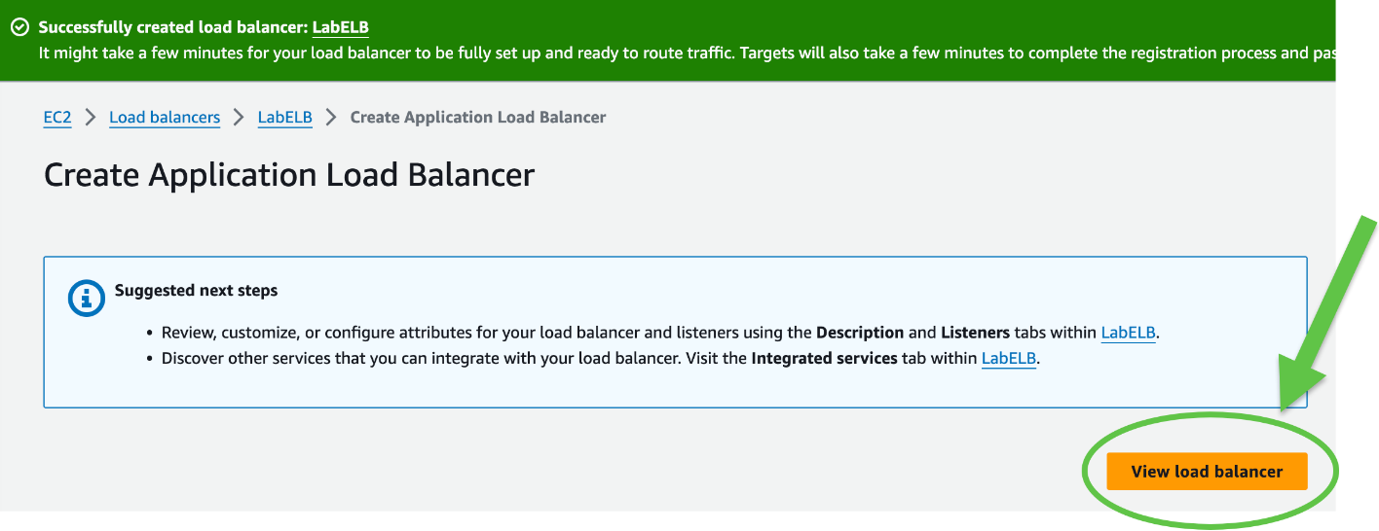

Task 3: Create a Launch Template and an Auto Scaling Group

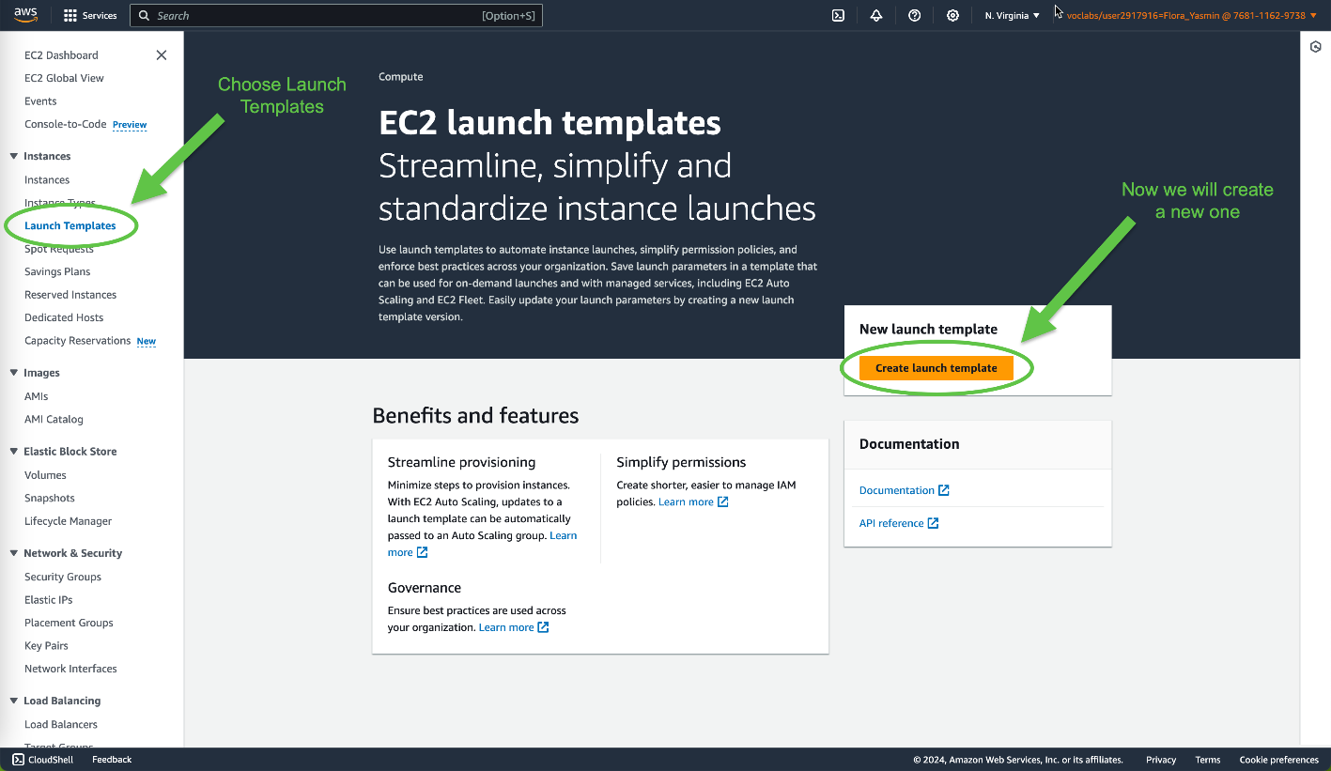

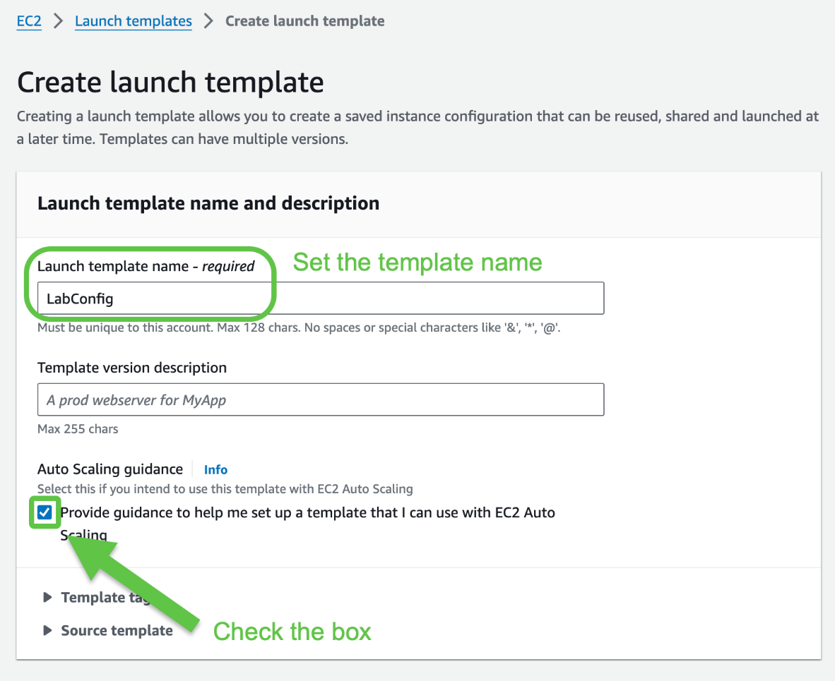

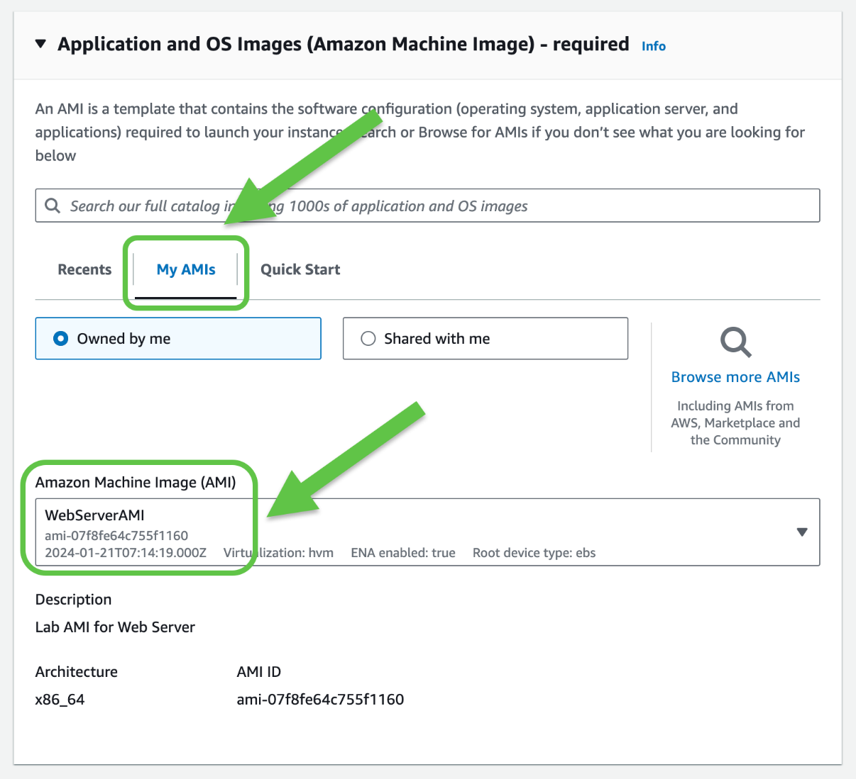

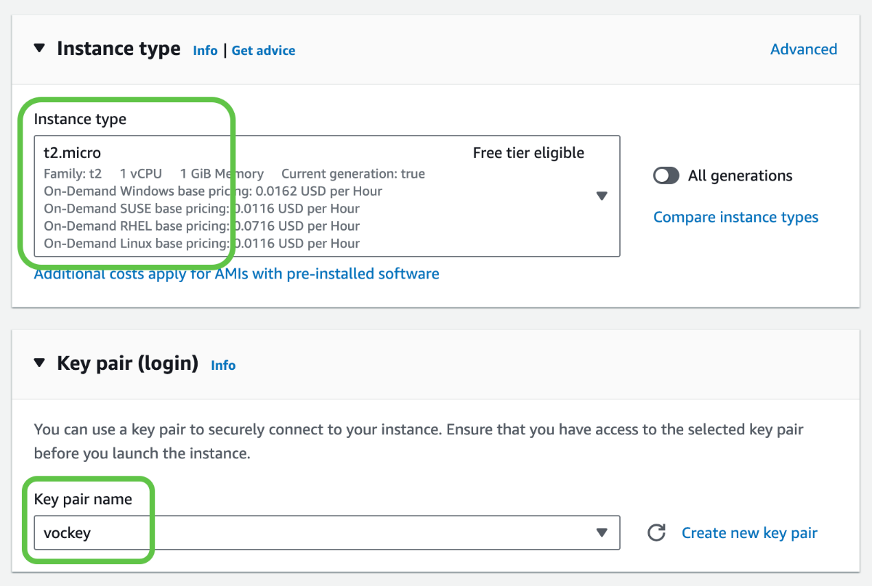

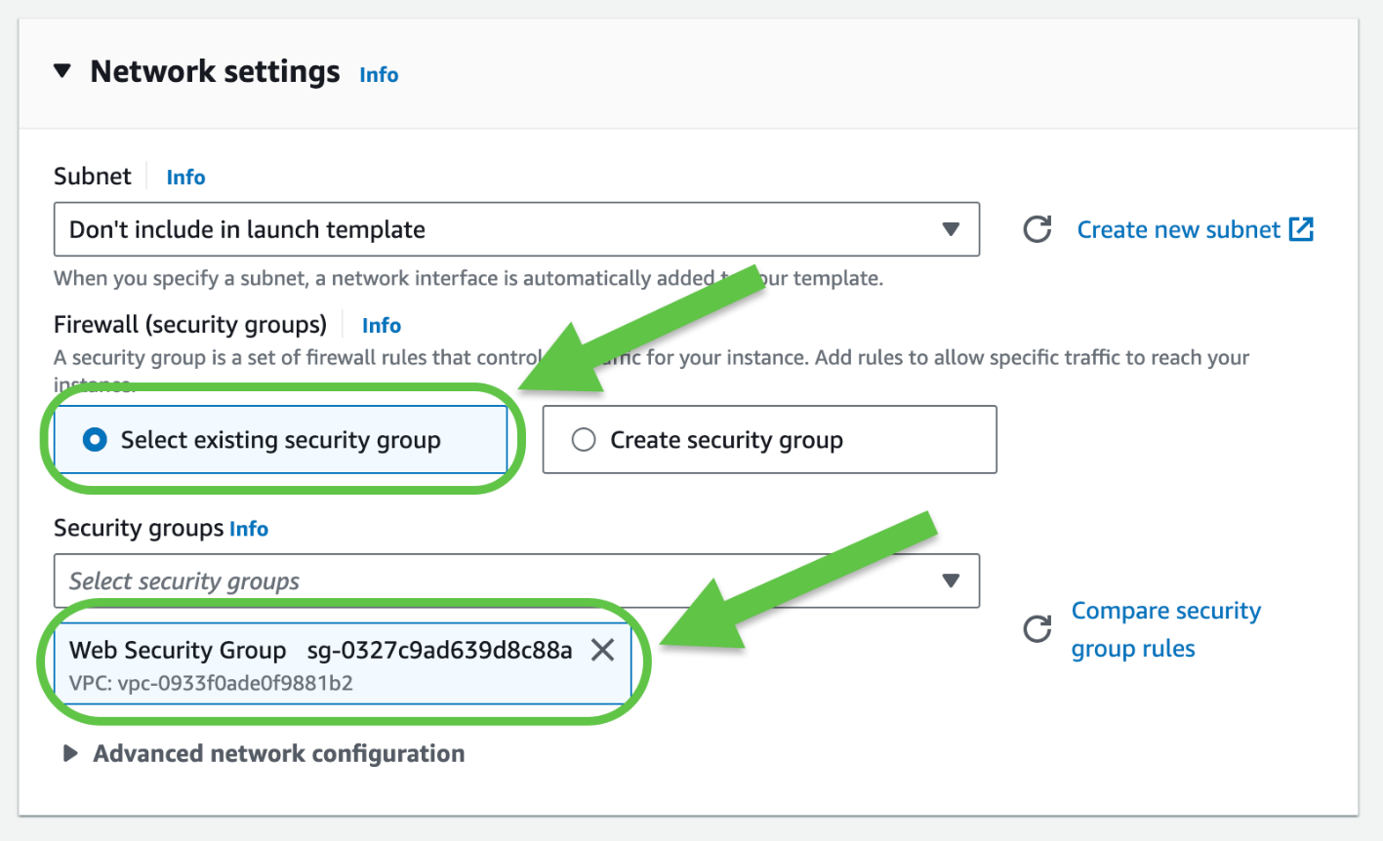



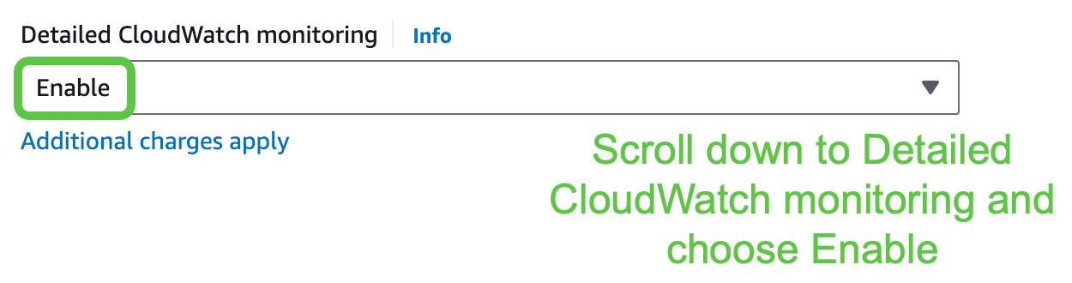

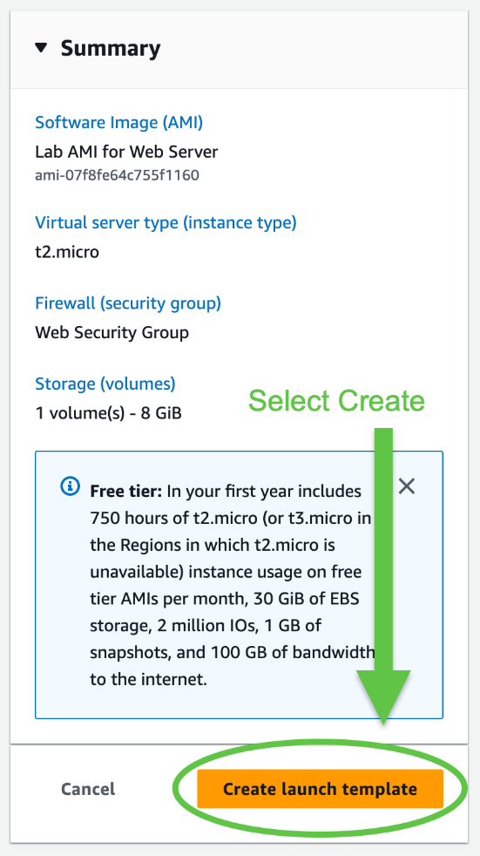

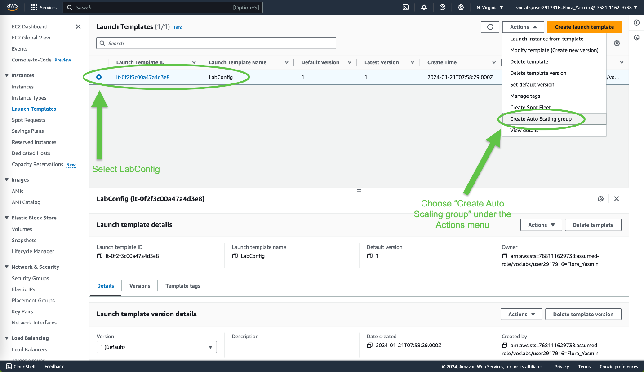

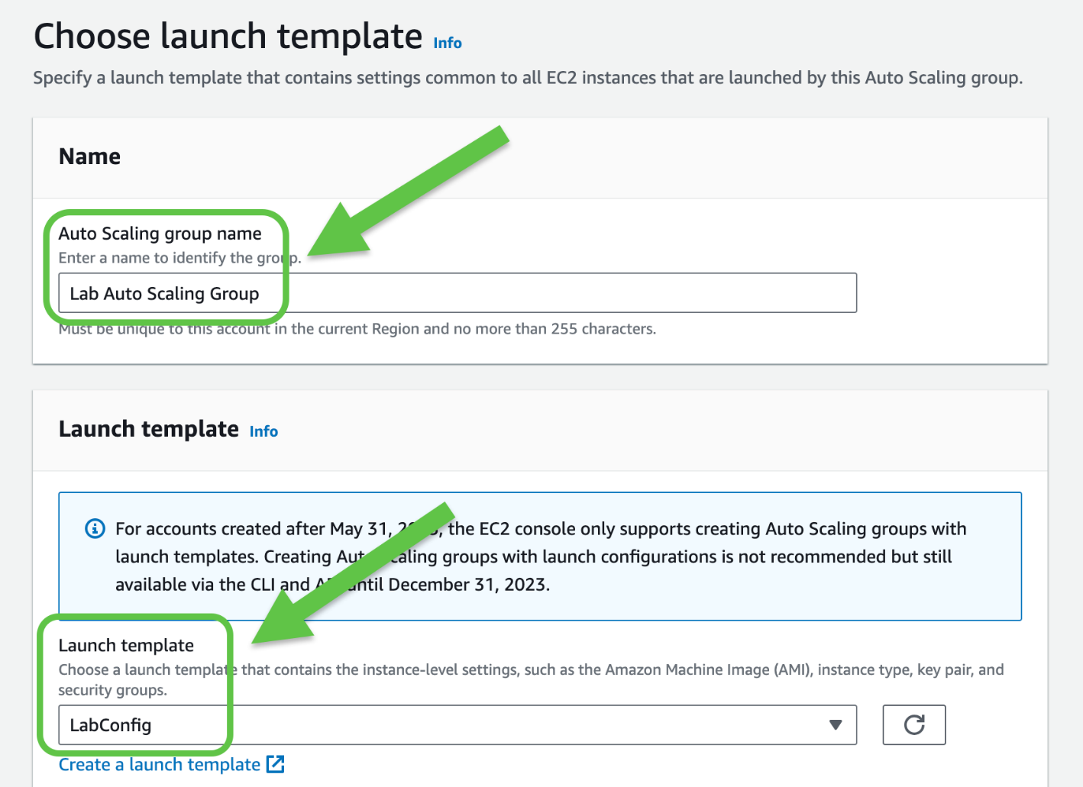



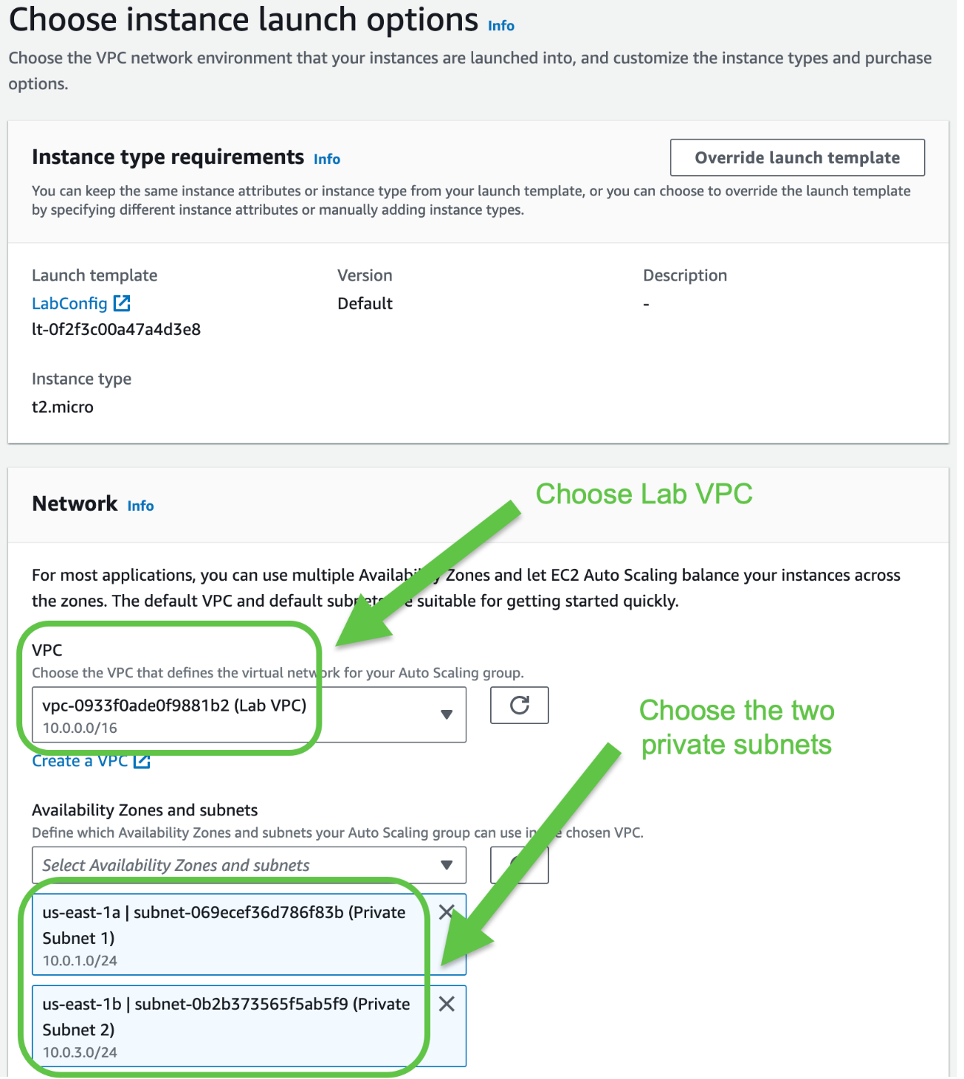



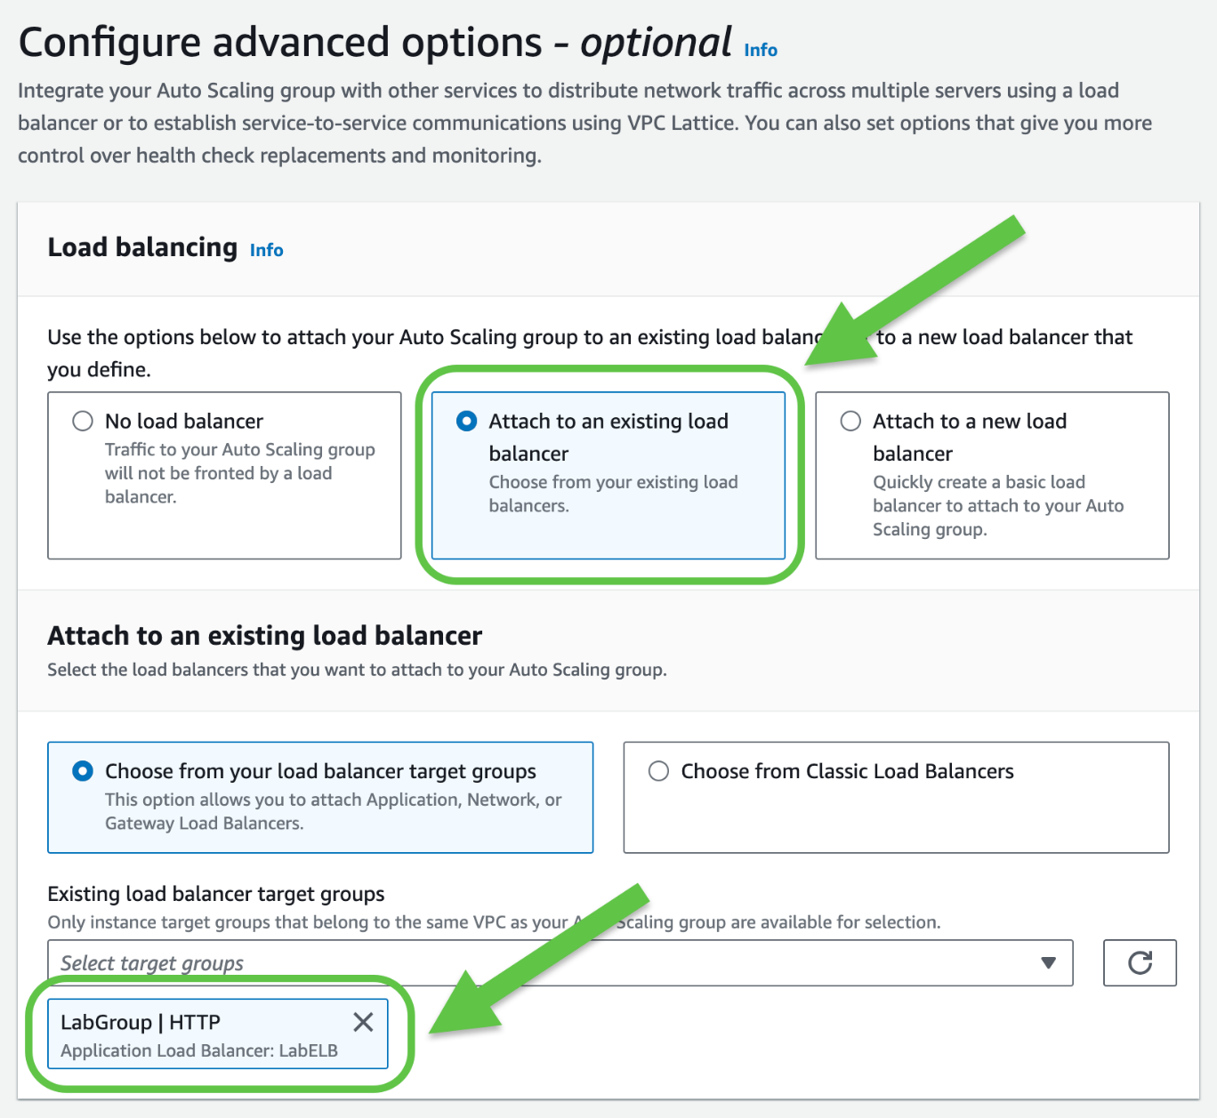

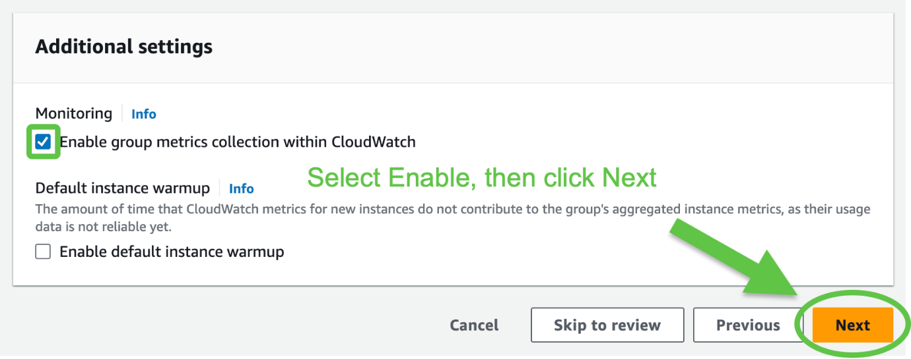

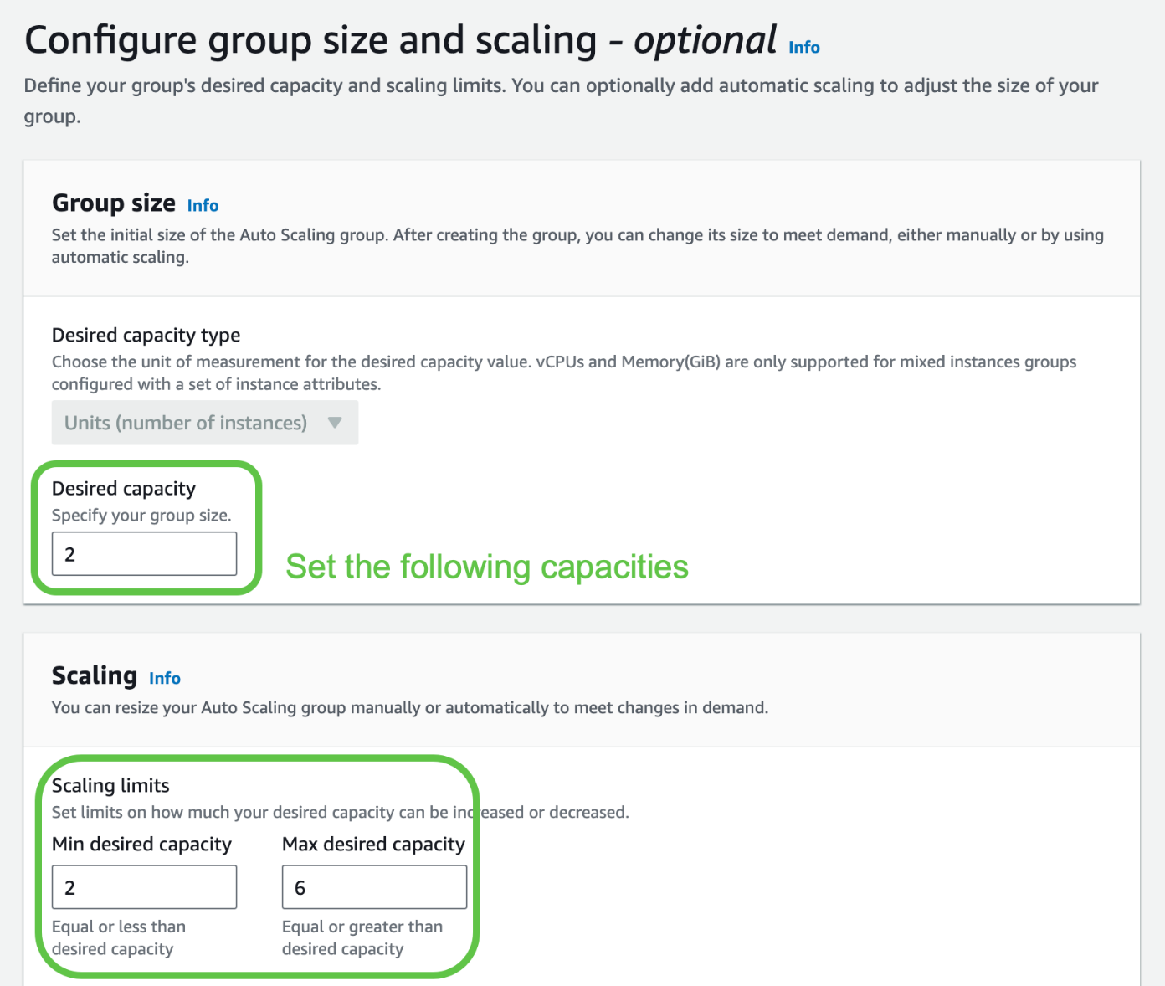

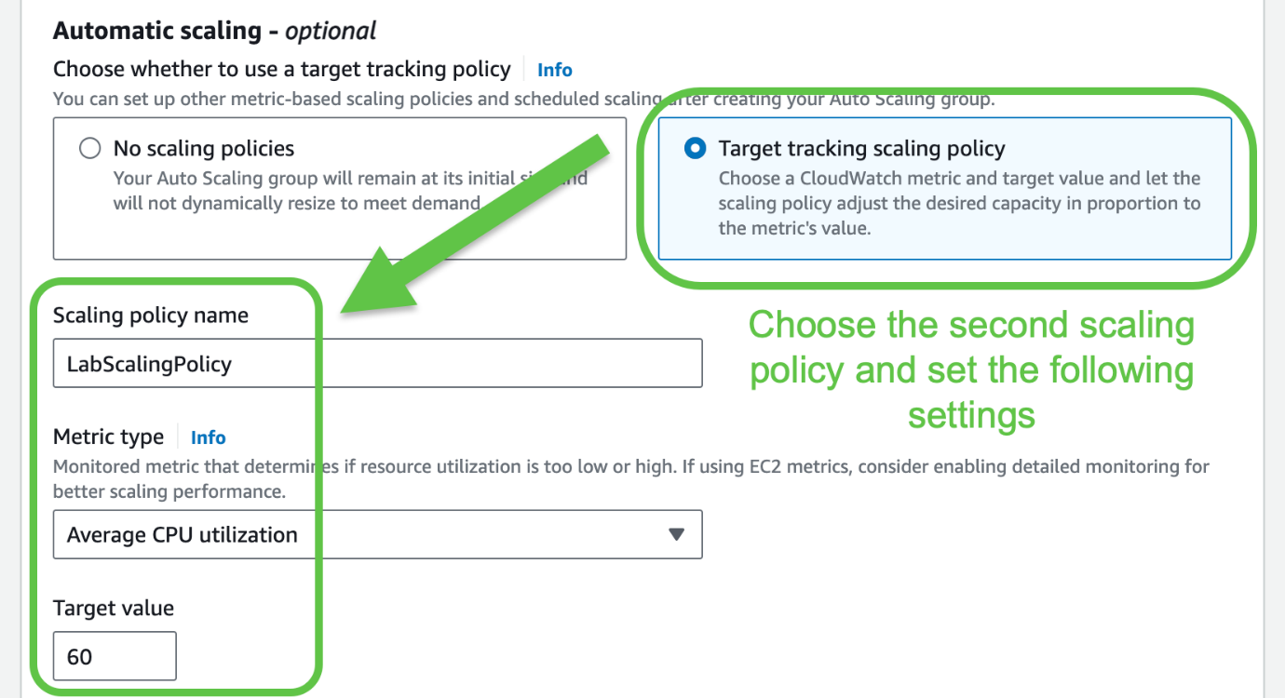



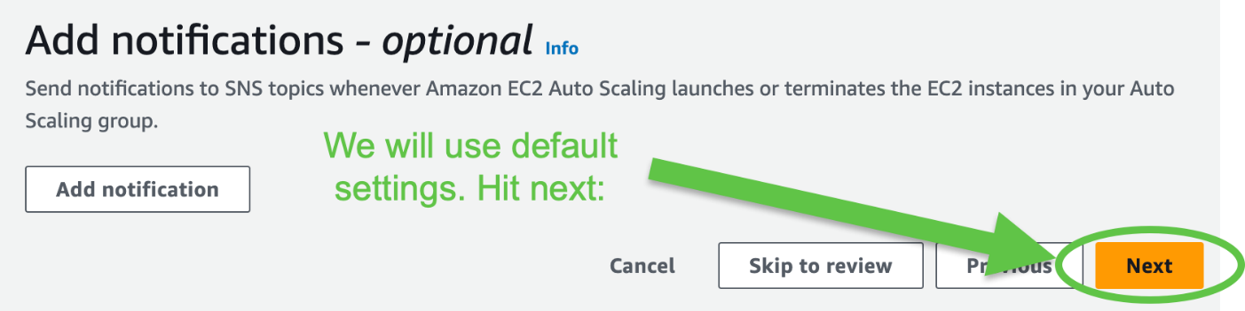

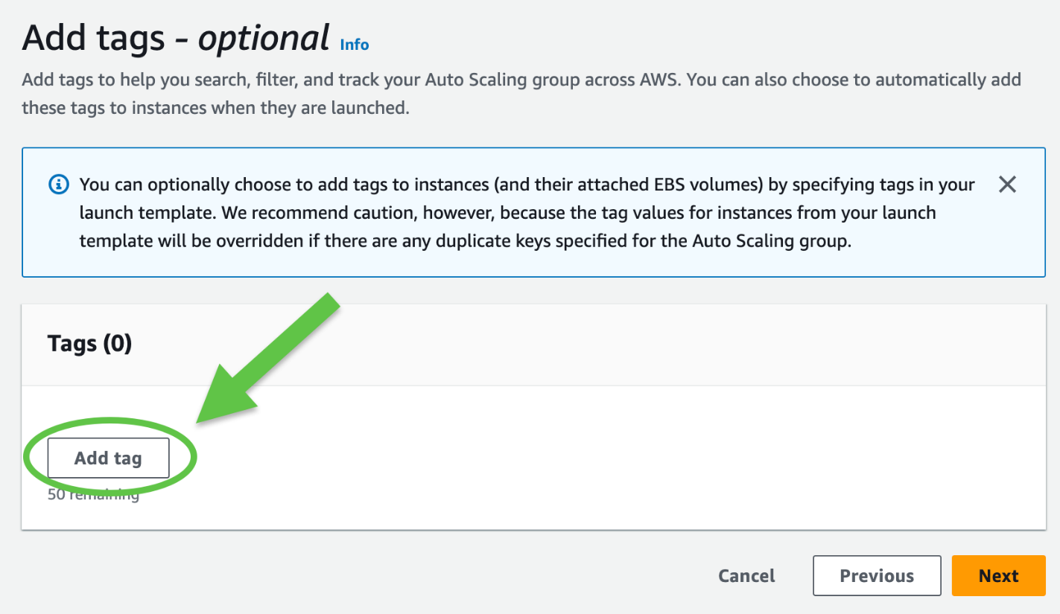

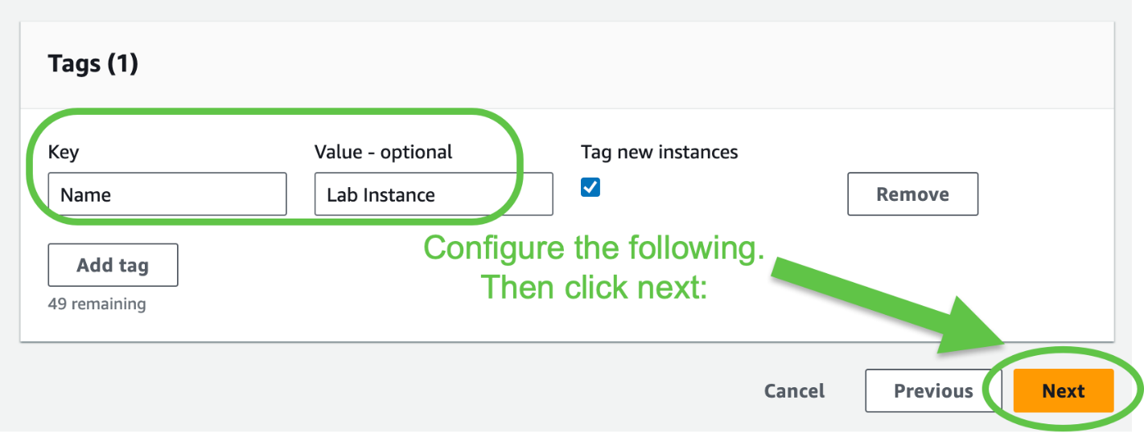



Task 4: Verify that Load Balancing is Working

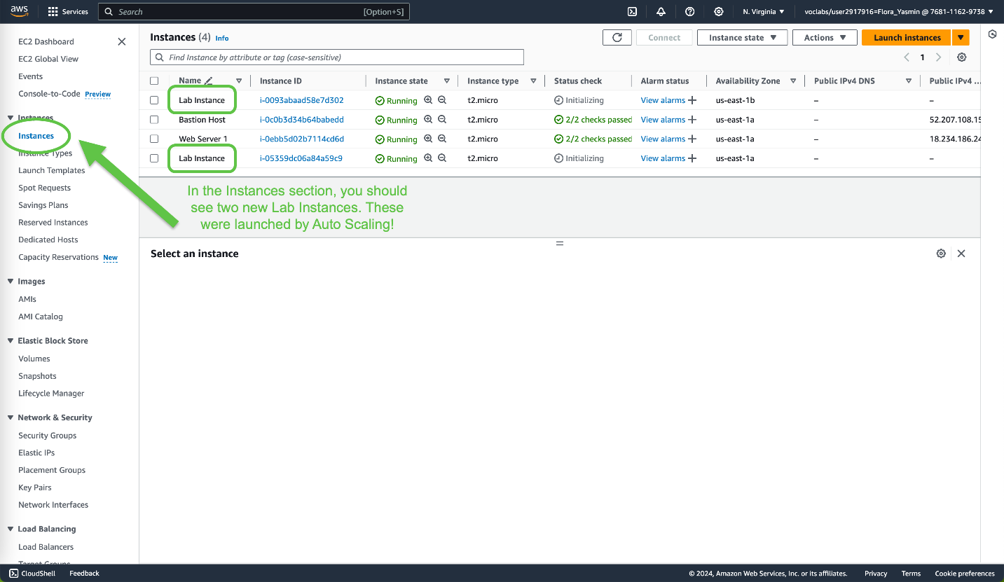

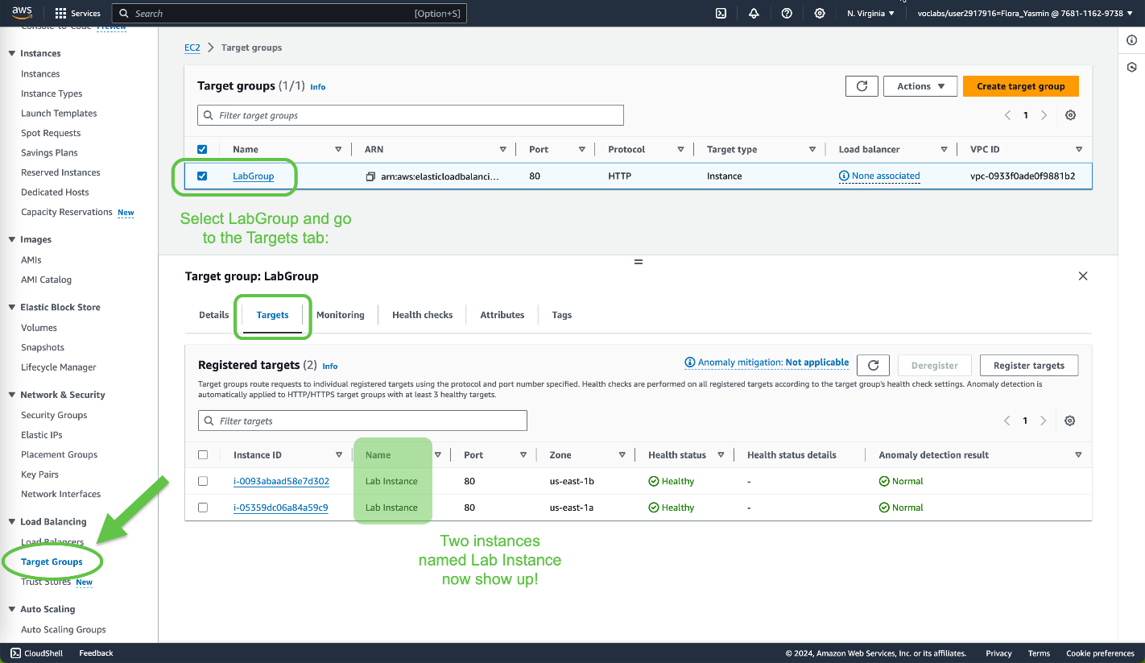

Notice how both of the instances have a health status of ”healthy.” This indicates that the Load Balancer will now send traffic to the instance. Now the Auto Scaling group can be accessed through the Load Balancer.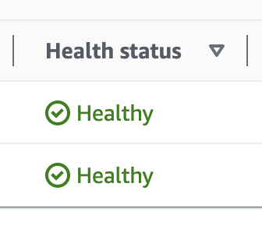

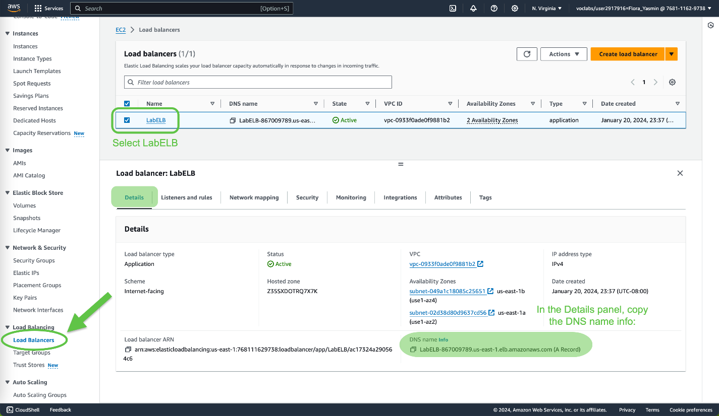

Paste the DNS name into a web browser:

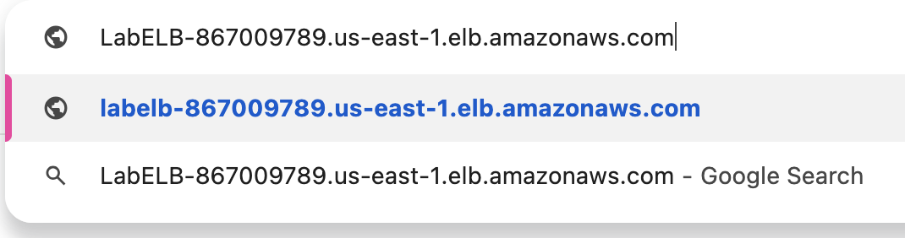

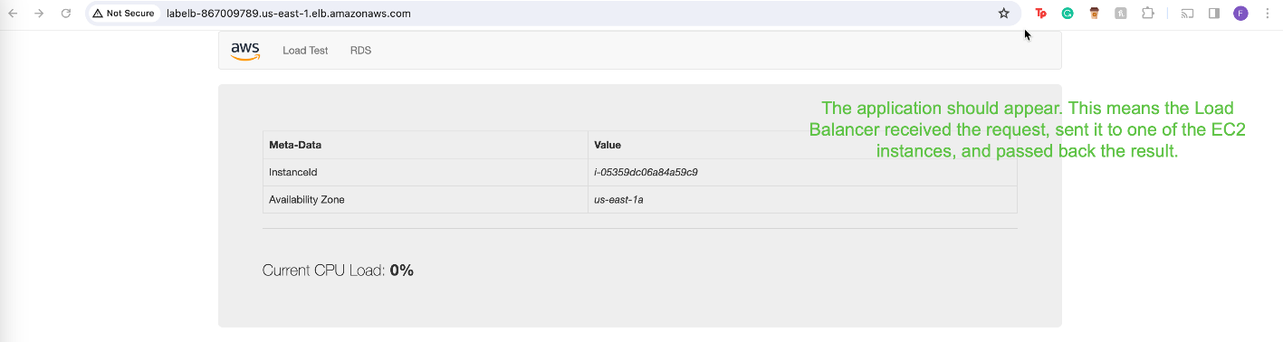

Task 5: Test Auto Scaling

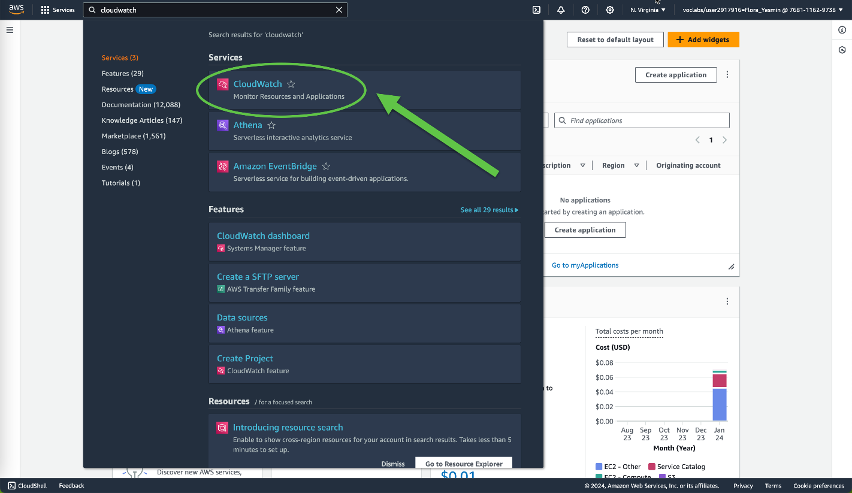

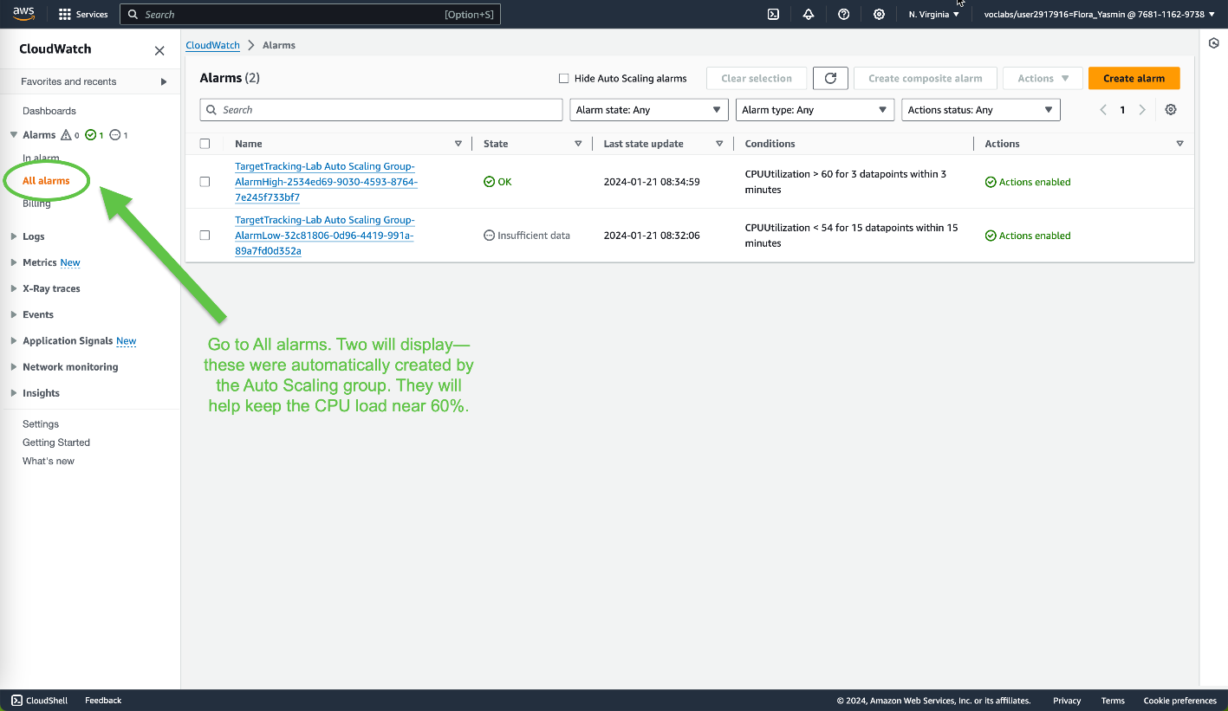

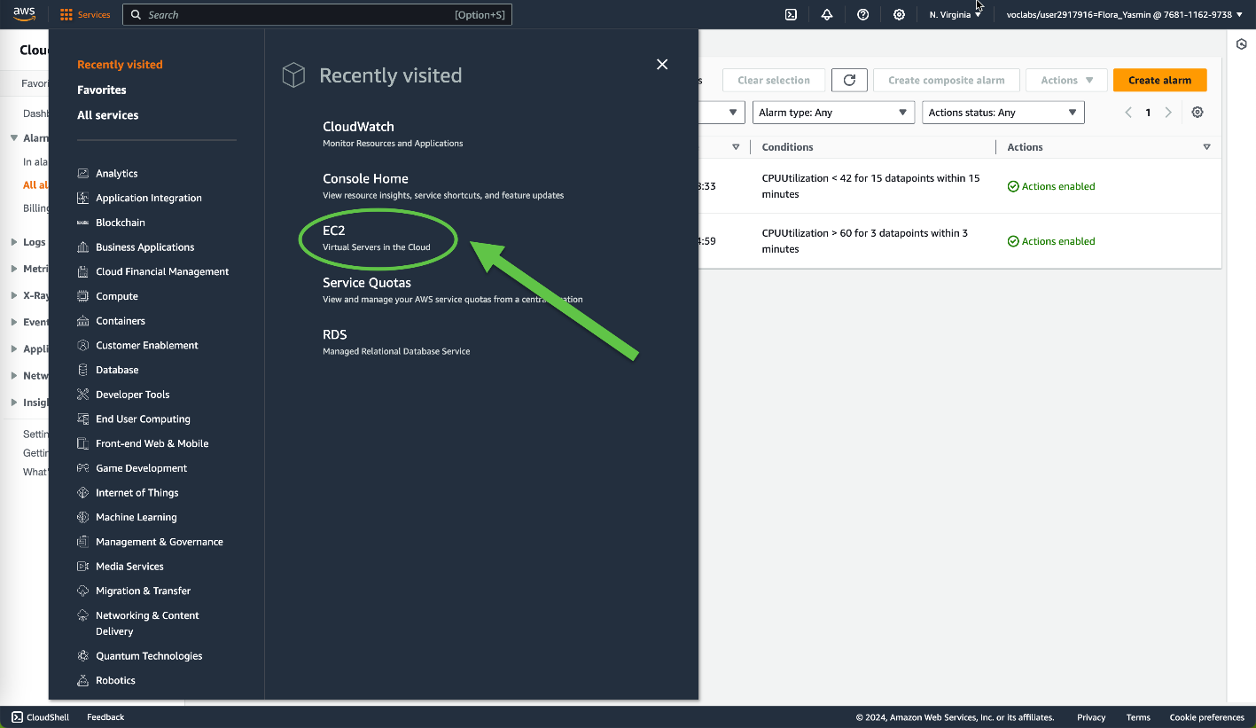

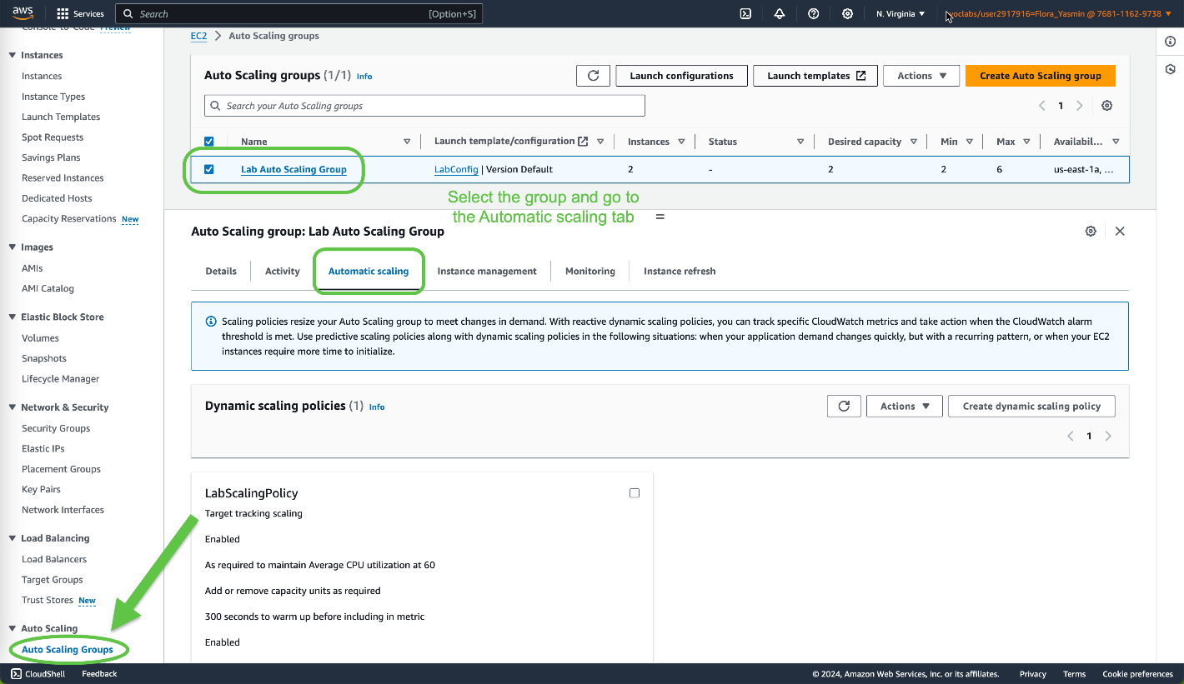

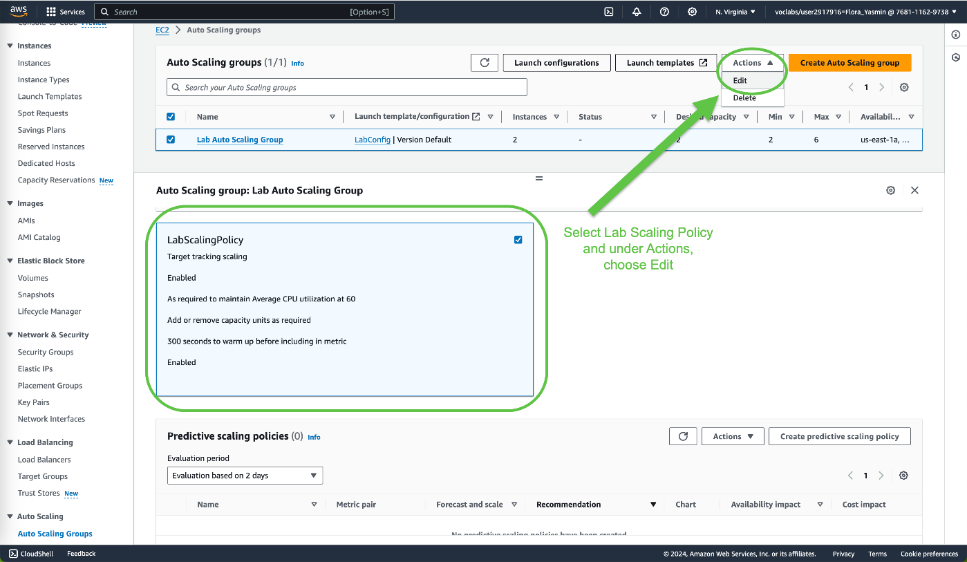

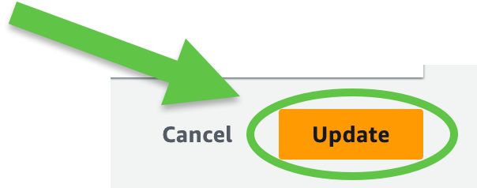

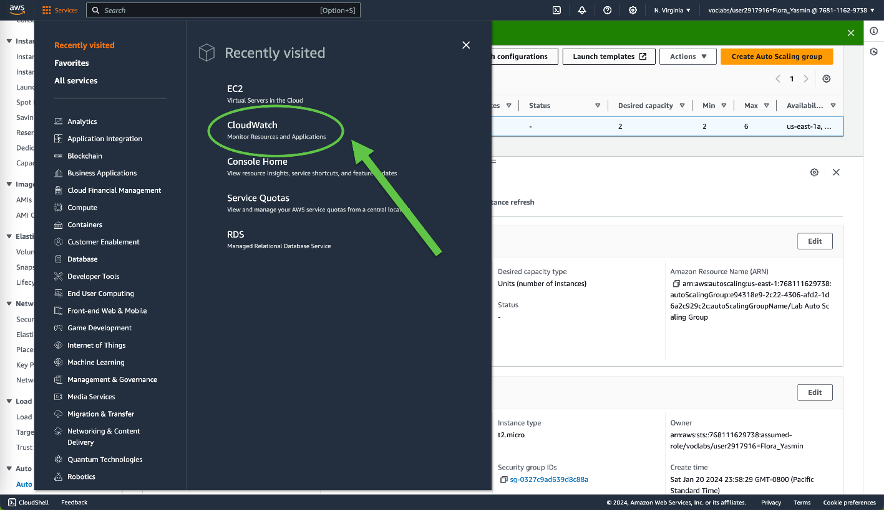

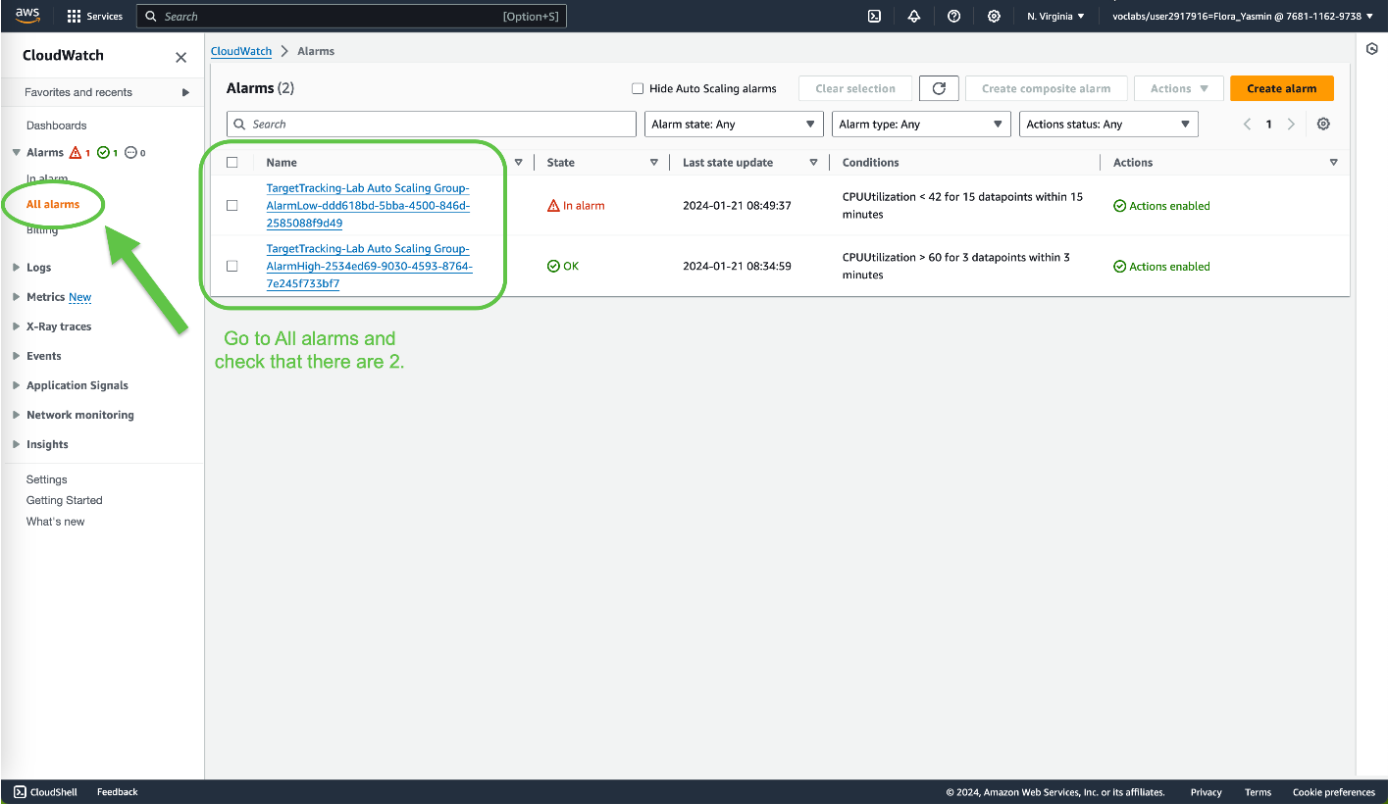

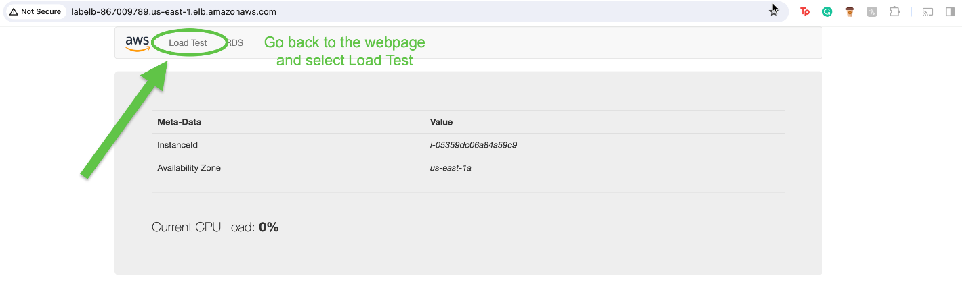

**Conclusion**

Completing this lab helps learn how to create an Amazon Machine Image (AMI) from a running instance, a load balancer, a launch template, and an Auto Scaling group. Amazon CloudWatch alarms can also be used to monitor infrastructure performance. It allows us to recognize the service’s ability to automatically scale new instances as well.